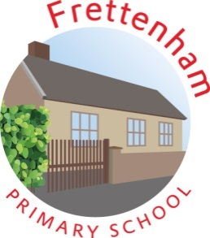

Frettenham Primary School Open afternoon for prospective parents and children starting in September 2020
We are holding an open afternoon: Wednesday, 16 October 2019
Come and see our wonderful school in action and experience some of our educational activities between 1.30pm – 2.30pm!

You will also have an opportunity to speak to Stacey Keeler (class teacher) and Gyles Longhurst (Head of School). We look forward to meeting you!
