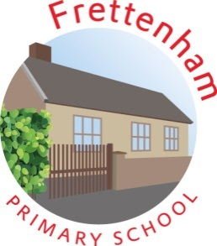

**Frettenham Primary School Open afternoon for prospective parents and children starting in September 2024**

We are holding an open afternoon: Monday, 16 October 2023

Come and see our wonderful school in action and experience some of our educational activities between 2.00pm-2.55pm

You will also have an opportunity to speak to Stacey Keeler (class teacher), Gyles Longhurst (Head of School) & Jenni Porter (Executive Deputy Headteacher). We look forward to meeting you!

