Norfolk Korfball Clubs – Junior Training
All are welcome to come along and try this fun mixed team sport.
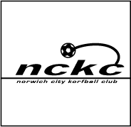
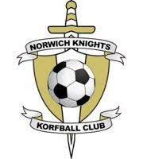

See below for training times/venue and the contact for more details.
Tuesdays at City of Norwich School
7:00 – 8:00pm Years 4-9
Contact - Phil Buttinger
07794 844497 or philipbuttinger@gmail.com

Wednesdays at Norwich High School for Girls
6.30-7.30pm Age 6-13 years
Contact - Malene
07534 285676

Wednesdays at The Open Academy, Heartsease
6.00 -7.15pm Years 4-8 (Age 8-13 years)
Contact - Charlie Williams
norfolkdragonskorfball@gmail.com

