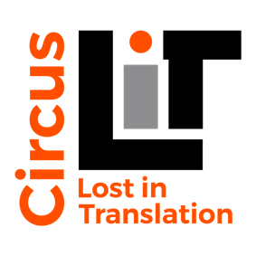
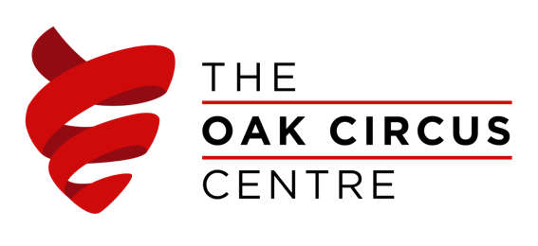

The Oak Circus Centre and Lost in Translation Circus are happy to announce that they are taking part to the Creativity and Wellbeing Week, promoted by the Culture, Health & Wellbeing Alliance, that will take place from the 18th to the 24th of May 2020.

As part of the initiative our internationally trained tutors will be offering several free classes in a range of circus disciplines.
Each class will be tailored to a specific age range, from pre-school children to seniors, and will not require any previous experience.
All the classes will take place on the online platform Zoom where the tutors will be able to interact with participants and give instructions and advice live.
To check out the class schedule and book your place follow the link https://theoakcircuscentre.org.

We are trying to create a positive event where everyone can access and enjoy the wellbeing benefits of our classes even during the lockdown. We know that creative and physical activities are more important than ever at the moment so join us online and let’s have some fun together!

STAY ACTIVE – STAY CONNECTED – STAY CIRCUS
All our classes are sponsored by Norwich Freemans Charity, Anguishes Educational Foundation and Arts Council England

