**Cut and Stick Sentence Ordering**

|  |  |  |  |
| --- | --- | --- | --- |
| C:\Users\Sean\AppData\Local\Microsoft\Windows\Temporary Internet Files\Content.IE5\5PX6Y09O\MC900417438[1].wmf | rat | on | sat |
| mat. | the | The |  |

|  |  |  |  |
| --- | --- | --- | --- |
| C:\Users\Sean\AppData\Local\Microsoft\Windows\Temporary Internet Files\Content.IE5\PGNWS7OV\MC900352444[1].wmf | The | food | the |
| was | in | pan. |  |

|  |  |  |  |
| --- | --- | --- | --- |
| C:\Users\Sean\AppData\Local\Microsoft\Windows\Temporary Internet Files\Content.IE5\PGNWS7OV\MC900436326[1].png | This | is | cat. |
| black | fat | a |  |

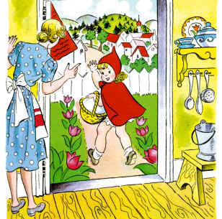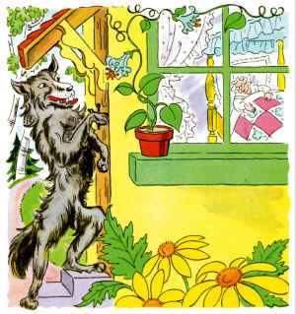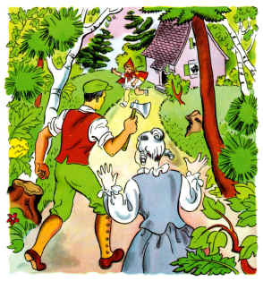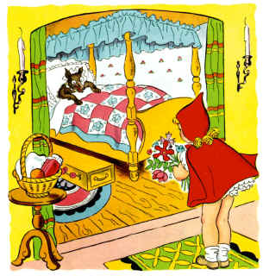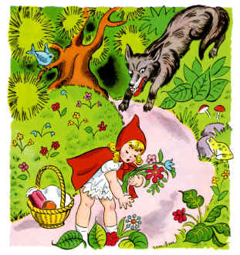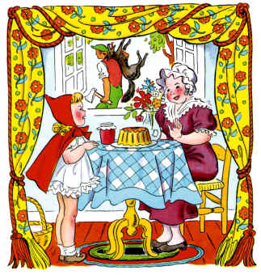

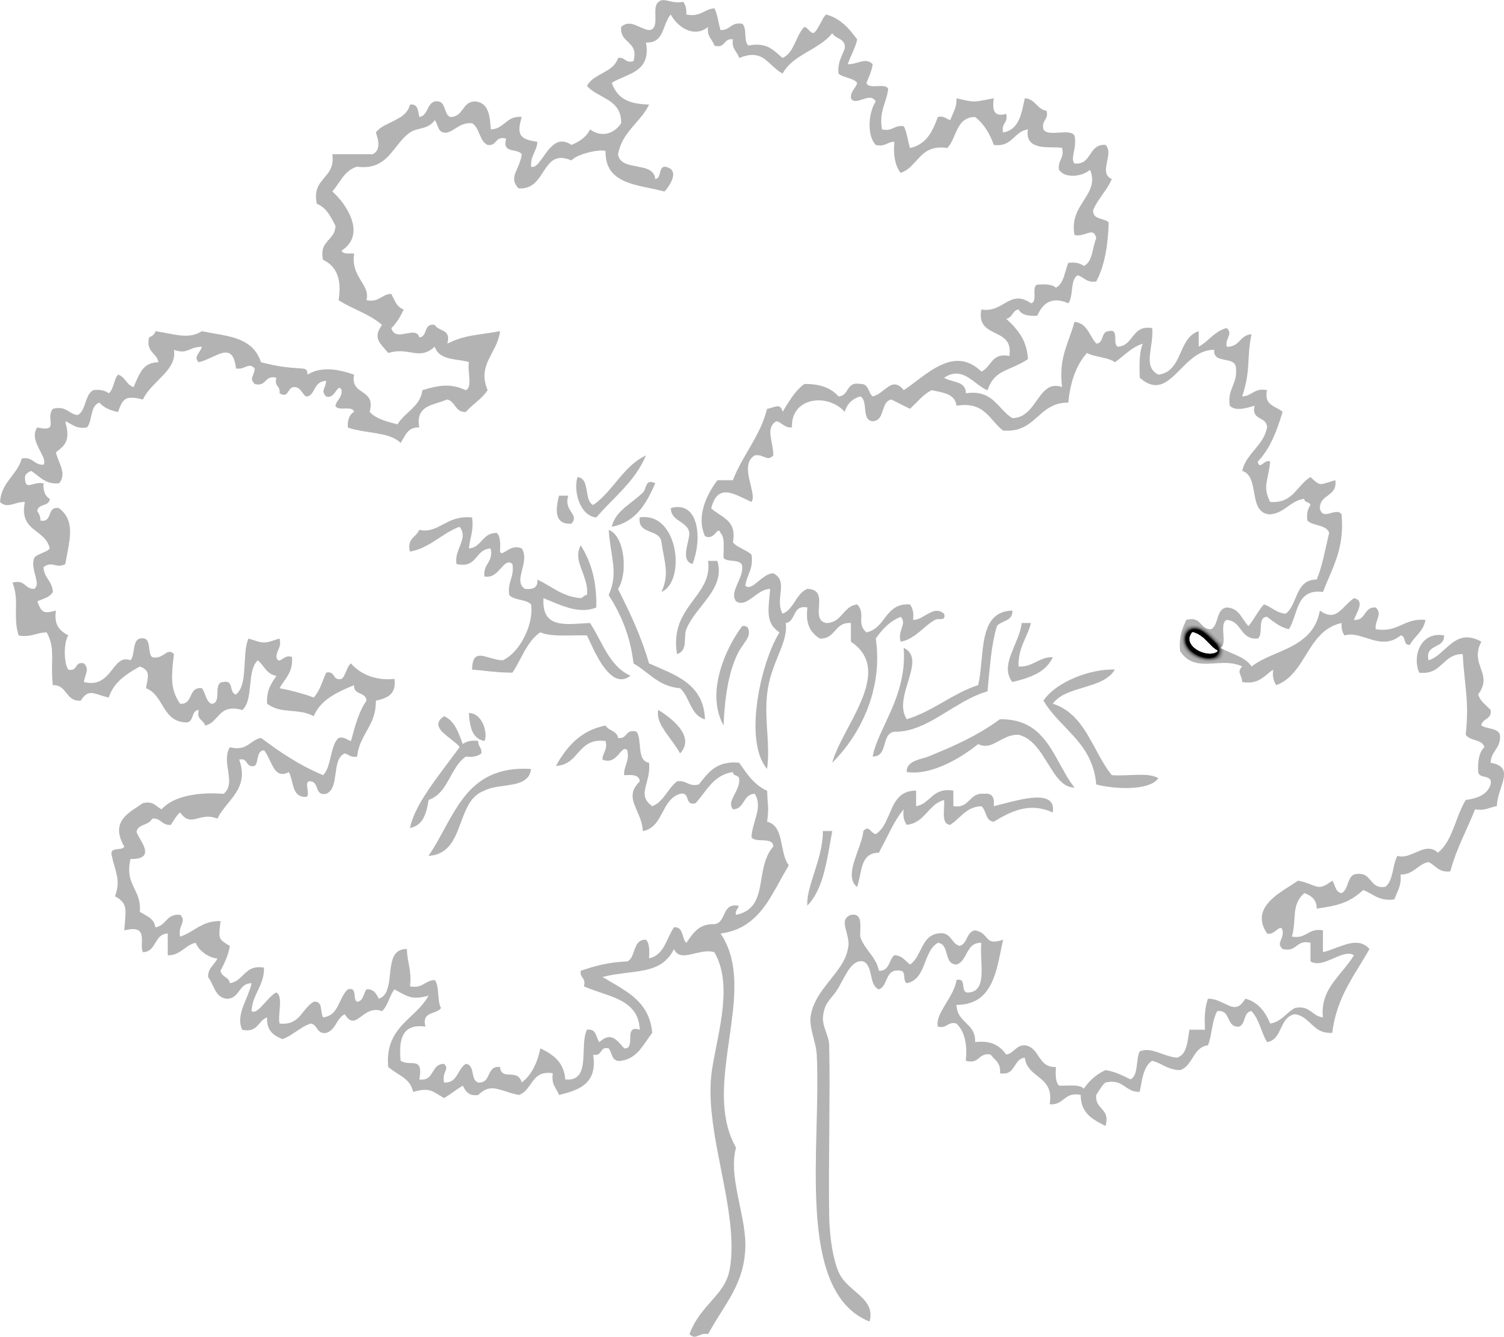

**O ______________________**

**a _____________________**

**k _____________________**

**T _____________________**

**r _____________________**

**e _____________________**

**e _____________________**

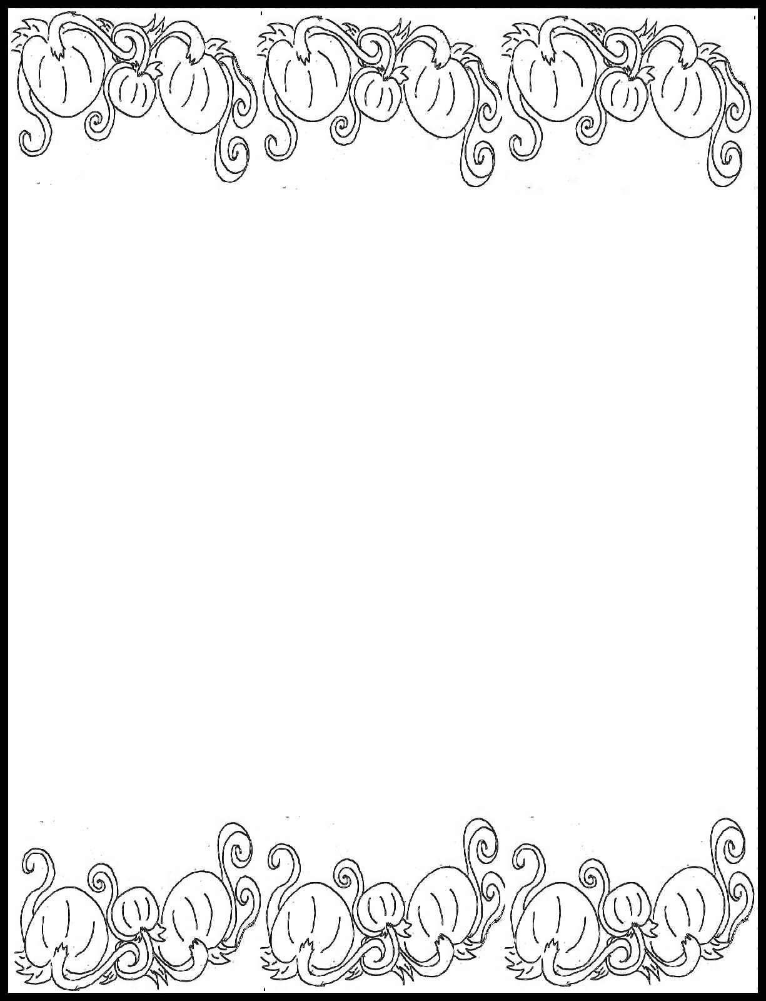

S _______________

P _______________

R _______________

I _______________

N _______________

G _______________

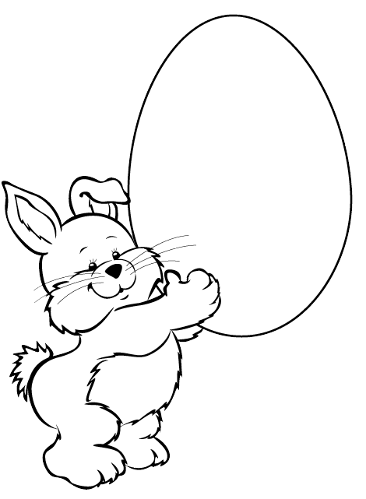

**E ________________**

**A ________________**

**S ________________**

**T ________________**

**E ________________**

**R ________________**