

***Friday 30 November 2018***

**Address: 16 School Road, Frettenham, Norfolk, NR12 7LL**

**E mail:** [**office@frettenham.norfolk.sch.uk**](mailto:office@frettenham.norfolk.sch.uk)

**Website:** [**www.harnserfed.co.uk**](http://www.harnserfed.co.uk)**.**

**Telephone: 01603 737405**

**Website:** [**http://www.stfaithsprimary.norfolk.sch.uk/**](http://www.stfaithsprimary.norfolk.sch.uk/)



**Children in Need**

Congratulations and thank you to everyone for joining us to fundraise for Children In Need. We have finally finished counting the 1p and 2p’s! This year we have raised:

2p collection = £16.28

1p collection = £32.54

Cake sale = £24.75

Book sale = £74.20

**Total = £147.77**

Finally, congratulations to Paul Cross, the Head of School Hainford, who completed the Brighton marathon in an amazing 3hrs 54mins. Well done!

I hope you join with me in wishing Mandy Foyster all the very best at the London marathon this Sunday. Go Girl! : )

We are still collecting Sainsbury’s Active Kids vouchers. There are still have a couple of weeks before the closing date so please bring in as many as you can.



**Uniform reminder**

Thank you to all parents who make sure their children are in the correct school uniform. Just a reminder the school uniform is:

* Red jumper or cardigan for Reception – Year 5
* Black jumper or cardigan for Year 6
* White or red polo t-shirt
* Black or grey school trousers or skirt
* Please ensure that there is a full PE kit at school every day, including a change of trainers.

Embroidered uniform can be purchased from Tesco online uniform shop.

**Nebula Tag Rugby Tournament**

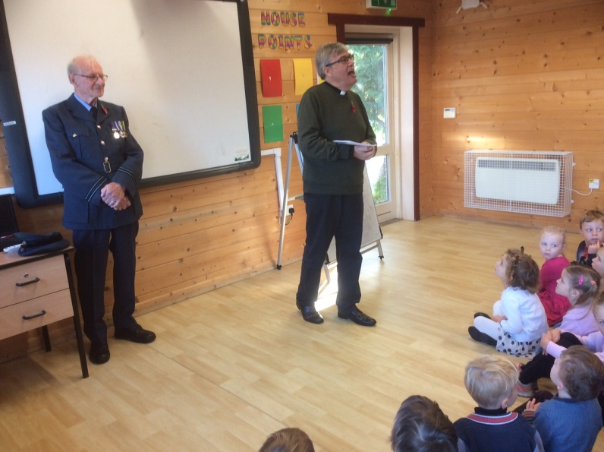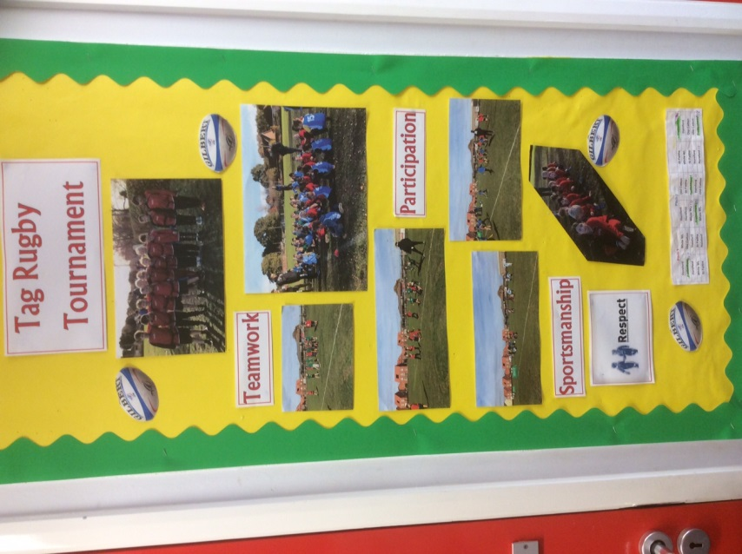

**Remembrance service**

**Gymnastic lessons, Class 2, at Old Catton Junior School**

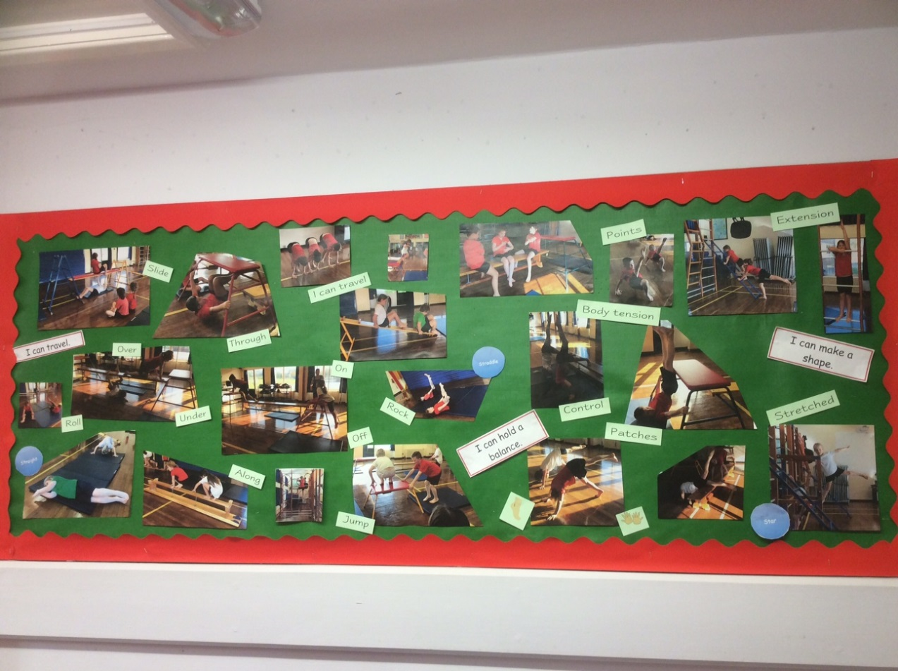

**Celebration Assembly**



|  |  |  |
| --- | --- | --- |
|  | **Star of the week** | **Value award** |
| Class 1 | Emily | Eddie |
| Class 2 | Jayden | Daisy |
| Class 3 | Oliver | Alfie |

**✔**

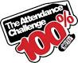

**Attendance Celebration**

|  |  |  |
| --- | --- | --- |
|  | Whole School | **94.94%** |
| 1st | **Class 2** | **96.52%** |
| 2nd | **Class 1** | **95.71%** |
| 3rd | **Class 3** | **92.58%** |



**Norse Catering**

Please ensure that all meals are paid for in advance.

[www.norsecatering.co.uk](http://norsecatering.co.uk/)

**Diary Dates**

Please see the accompanying schedule of dates for the remaining term,

but do be aware that they are still subject to change.

**Children in need, fundraising, 2018**

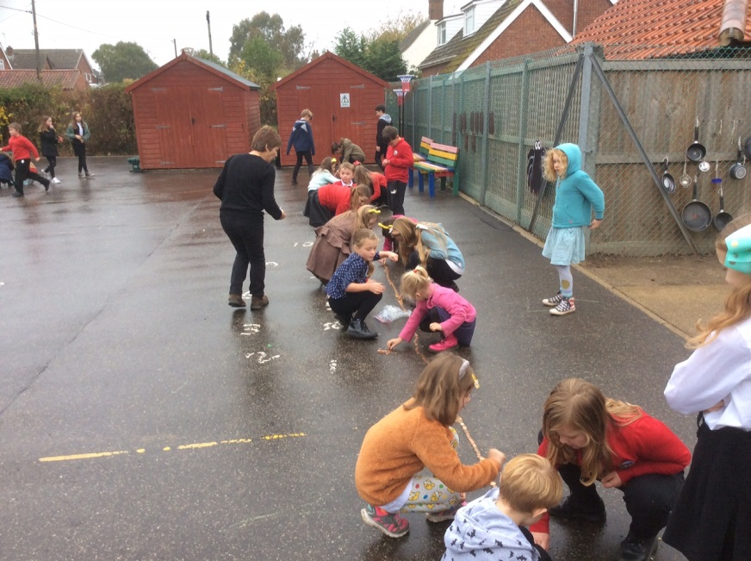

1p and 2p, playground line trail

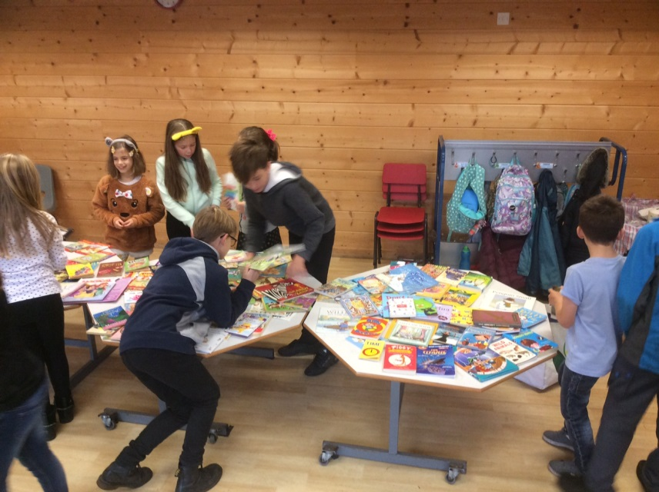

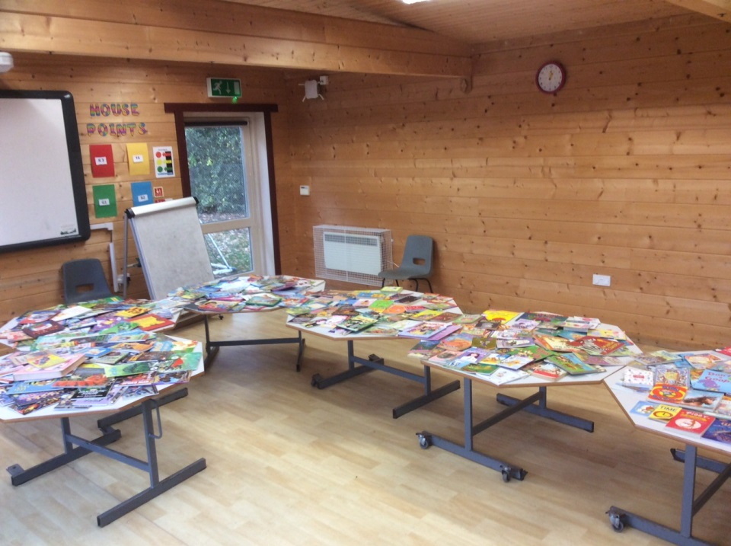

**Dates for your diary**

***Autumn Term***

***Celebration assembly: Friday at 2.30pm***

**December 2018**

3 December 2018 Reception height and weight

12 December 2018 Nativity Class 1 & Class 2. 1.30pm and 6.00pm at Frettenham Church. *Friends selling teas and mince pies.*

13 December 2018 Rocksteady concert 2.15pm (everyone welcome)

14 December 2018 Christmas Friends Disco (save the date)

18 December 2018 Christmas lunch (please order with the office before 30.11.2018)

18 December 2018 Christmas Carol Service at 10am – all welcome at the Frettenham Church.

18 December 2018 Last day of Autumn Term

**Spring term**

3 January 2019 First day of the Spring term

6 February 2019 Nebula Cross Country at Horsford School

15 February 2019 Last day of Spring half term

25 March 2019 Reading week

28 March 2019 Luke Temple author visit

29 March 2019 Luke Temple book signing

3 April 2019 Nebula Cricket

5 April 2019 Last day of the term

**Summer term**

23 April 2019 Start of Summer Term

6 May 2019 May day Bank Holiday

8 May 2019 Nebula KS1 Multi skills event

24 May 2019 Last day of the Summer half term

28-29 May 2019 Skillforce camp at White Woman Lane School

3 June 2019 First day of Summer half term

10 June 2019 Year 4 cycle training (afternoon)

11 June 2019 Year 5&6 cycle day. Helpers required for the afternoon.

12 June 2019 Year 5 and 6 cycle training all day, helpers required all day.

19 June 2019 Nebula cricket

1-4 July 2019 City Sports (selected pupils)

10-12 July 2019 Year 3 and Year 4 residential trip to Whitwell Hall

24 July 2018 Last day of the Summer term.

**Rocksteady Music Lessons**

Rocksteady Music Lessons The children who have been attending Rocksteady music sessions with James this term will be performing a small rock concert on 13 December 2018 at 2.15pm Everyone is most welcome. Why not come along to celebrate the children’s accomplishments and perhaps see if this is something your child may like to become involved in next term?

**Skilforce- Year 5**

Year 5 pupils were sent a letter home regarding the Skillfoce programme which will start on 8 January 2019. Please note, as on the letter, the collection time is at 4.20-4.30pm from the Frettenham School.

**Christmas carol service**

We welcome everyone to join us for our Christmas Carol Service on 18 December 2018 at 10am, at the Frettenham Church.

**Friends Christmas Disco**

The Friends have organised a fundraising Christmas Disco for the children on 14 December 2018 at the Frettenham Village Hall. More details to follow!

**Nativity- The very hopeless camel**

We are pleased to confirm that this year our Nativity will be on 12 December 2018 at 1.30pm and 6.00pm at the Frettenham Church. This will be performed by Reception, Year 1, Year 2 and Year 3. We welcome all parents and carers, grandparents and friends to join us to enjoy the performances. The School Friends will be selling warm drinks and mince pies. If you require any additional information please do not hesitate to speak with Mary or Stacey.

**O2 – Young Voices**

Children have been practicing the songs for the Young Voices concert in February. Please could we ask you to encourage your children to practice at home. The soundtrack is available to download via Spotify or Apple Music and your child should have the song tracks on the supplied CD.



**School Disco – Friday, 14 December 2018**

Message from the Friends: The disco will be from 5.30 -7pm. £4 per child which includes a drink and biscuit and there will be a visit from Santa. We will be selling sweets. Letter to be sent home next week.

**Message from Gyles**

Thank you for making our new morning routine run smoothly this week (although three of them would have been wet mornings anyway!, I have had lots of positive comments and also noticed the road outside school is less congested with traffic, which is also an unintended positive too.

Please check through the list of dates so you are aware of what is happening when and come and ask any questions if you are unsure if you child is involved in a particular event.

I have heard lots of chat about Christmas and have even spotted a Christmas jumper! Many children are talking about the latest games and technology that is going onto their Christmas lists.  With this in mind I have attached a link to Netaware which has lots of advice and information about the suitability of games and apps.

<https://www.net-aware.org.uk/>

Also please could I ask you to sign this petition from the NSPCC who are trying to make the Government keep their promise of a social media law to regulate social media companies more closely.

<https://www.nspcc.org.uk/what-we-do/campaigns/wild-west-web/>

***Friday 30 November 2018***