COMMUNITY FOCUS North and Broadland

WEEKLY BULLETIN

Date: 17th April 2020

**Due to the current situation with the Corona Virus Pandemic we are sharing some information which you might find helpful.**

**If you would like to update us on your own organisation, current operating capacity, contingency plans for your service users or any other information then please do contact us at:-**

[**cs.cfoteam.nandb@norfolk.gov.uk**](mailto:cs.cfoteam.nandb@norfolk.gov.uk)

**This bulletin has 5 main subsections:**

* **Advice and Guidance**
* **Support Services (With a focus on Mental Health Support Services)**
* **Resources**
* **Finance / Funding / Grants**

|  |
| --- |
| **Broadland District Council**  **Coronavirus**  If you are classed as vulnerable and in need of support, please contact our dedicated helpline on **0344 8008020, Monday to Friday 09:00 - 17:00 and Saturdays and Sunday 10:00 - 16:00.**  **Easter weekend hours: Friday and Monday - 10am- 4pm. Saturday and Sunday closed.**  If you are a resident and need financial support call **01508 533933, Monday to Friday 08:15 - 17:00. Easter weekend hours: Friday and Monday 09:00 - 17:00 and Saturday/Sunday 10:00 - 16:00.**  If you would like to make a claim for Council Tax Reduction or Housing Benefitplease [**apply online here**](https://www.broadland.gov.uk/info/200126/benefits/215/apply_for_housing_benefit_and_council_tax_reduction)  [**https://www.broadland.gov.uk/coronavirus**](https://www.broadland.gov.uk/coronavirus) |

* **Volunteering / Training**

**ADVICE AND GUIDANCE**

**North Norfolk District Council**

**Vulnerable Person**

If you know of a vulnerable or at risk individual in North Norfolk, please tell us.

[**Let us know**](https://forms.north-norfolk.gov.uk/outreach/Vulnerable_Person.ofml)

**Contact Us**

Use our [online form](https://forms.north-norfolk.gov.uk/outreach/contactus.ofml) to get in touch.

**Email:**[NNDCCovid19@north**-**norfolk.gov.uk](mailto:nndccovid19@north-norfolk.gov.uk)

**NNDC Coronavirus Help Hub:**

**01263 516000 Monday to Friday, 8am to 8pm.**

**Or at weekends - 0344 800 8020 between 10am and 4pm.**

**Community Volunteers Groups**

We are asking for any volunteer groups offering services to those in need to register their details.

[**Sign up**](https://forms.north-norfolk.gov.uk/outreach/NNDC_volunteers.ofml)

**Covid-19 Response Parking Permit**

If you are a member of a medical or care group or working on behalf of the COVID-19 response. You can apply for a free COVID-19 Response Parking Permit which enables you to park without paying.

[**Find out more**](https://www.north-norfolk.gov.uk/tasks/your-community/covid-19-response-permit-for-free-parking/)

**Frequently Asked Questions**

Your questions answered on Coronavirus and the following services:

* [Council Tax](https://www.north-norfolk.gov.uk/tasks/council-tax/frequently-asked-questions-council-tax-and-coronavirus/)
* [Benefits](https://www.north-norfolk.gov.uk/tasks/benefits/frequently-asked-questions-your-benefits-and-the-coronavirus/)

**Safeguarding adult’s advice for Coronavirus volunteers**

[Click here for NSAB’s COVID-19 page](https://www.norfolksafeguardingadultsboard.info/professionals/coronavirus-covid-19/)

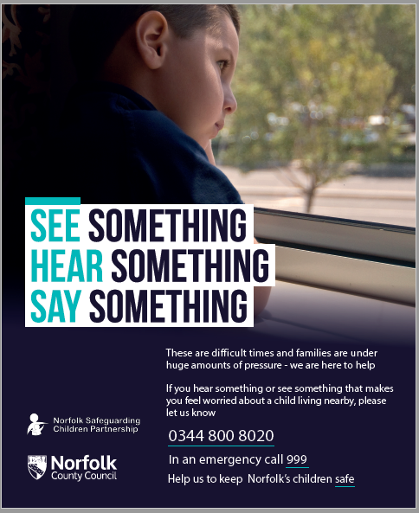

**SUPPORT SERVICES**

**Food and shopping updates**

**Foodbanks**

**Cromer and District:**

Tel: 07826 376343 (Monday to Friday 9am – 3pm)

Email: [info@cromerdistrict.foodbank.org.uk](mailto:info@cromerdistrict.foodbank.org.uk)

Website: [www.cromerdistrict.foodbank.org.uk](http://www.cromerdistrict.foodbank.org.uk/)

**Mid Norfolk:**

Email: [info@midnorfolk.foodbank.org.uk](mailto:info@midnorfolk.foodbank.org.uk)

Website: [https://midnorfolk.foodbank.org.uk](https://midnorfolk.foodbank.org.uk/locations/)

**Norwich:**

Email: [admin@norwich.foodbank.org.uk](mailto:admin@norwich.foodbank.org.uk)

Website: [www.norwichfoodbank.co.uk](http://www.norwichfoodbank.co.uk)

**Shopping**

Many supermarkets now provide volunteer shopping cards, to enable family members, friends or volunteers to shop safely for vulnerable and shielding adults and families. Some information on this is detailed in the table below, alternatively see the website of the store in question for more information. The table below shows the current dedicated shopping times for NHS staff, vulnerable and elderly.

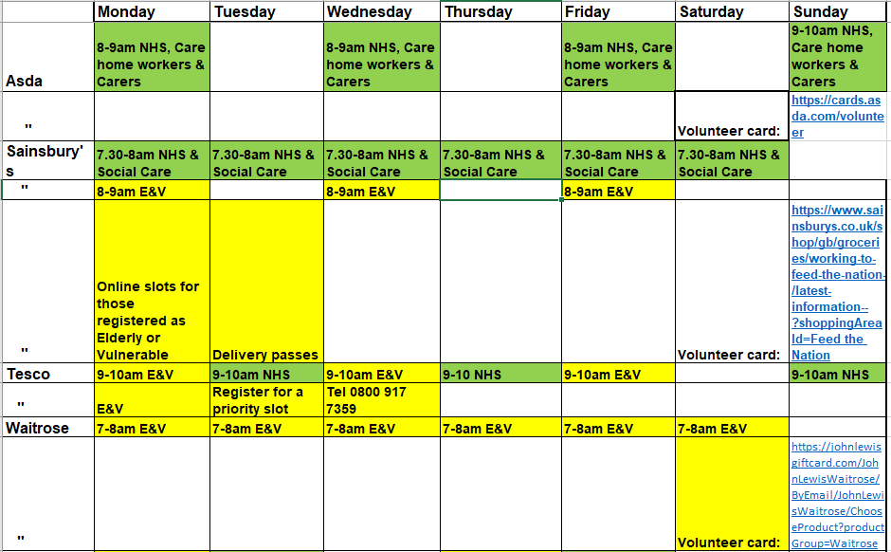

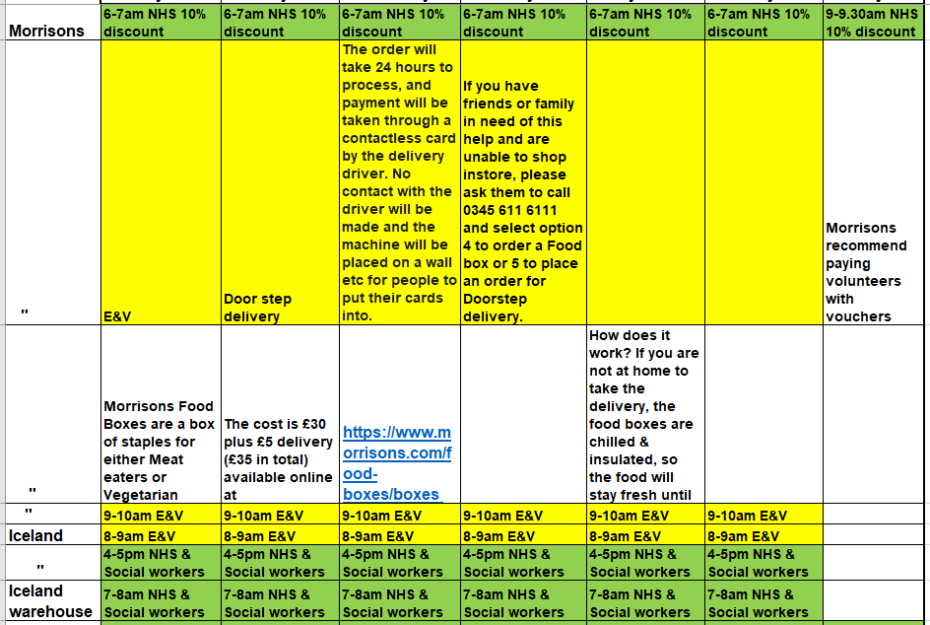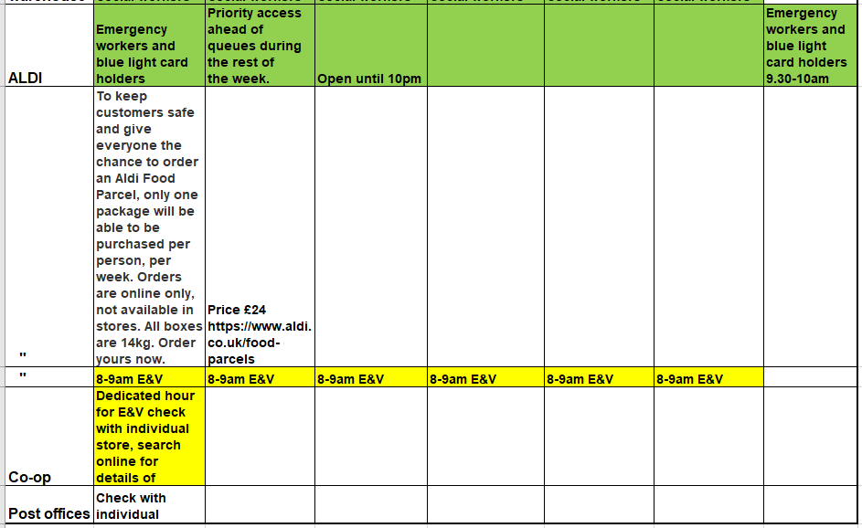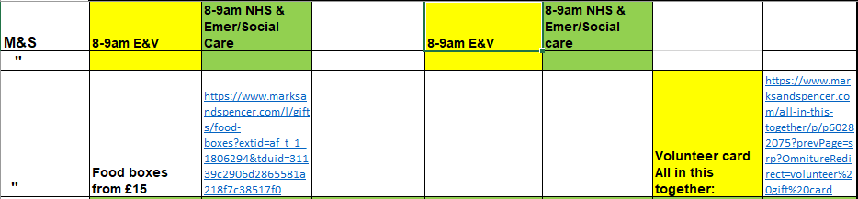

**Mental Health support services**

**The Help Hub**

If you have found yourself on your own and feeling isolated and fearful - we are here to help.

We are a group of qualified therapists who are giving our time freely to help people in your situation. If you would like a 20 minute chat on Skype, FaceTime or on the telephone, you can book a session with us through our calendar and we will contact you at the relevant time.”

<https://www.thehelphub.co.uk/>

**Online Stress Control class**

“As the NHS and HSE can’t deliver our Stress Control classes in the community just now, Dr Jim White will, instead, live-stream the classes, free-of-charge, starting on Monday 13th April. You can watch the sessions either in the afternoon or evening. Click here to get all the [dates](https://stresscontrol.org/stress-control/dates/). To find out more about Stress Control click [here](https://stresscontrol.org/stress-control/stress-control/)

All you need to successfully complete this class is to watch each of the six sessions, read the booklets and use the relaxation and mindfulness. You can find the sessions on YouTube.

Click the button below or search for ‘Stress Control 2020’ to access our YouTube channel where the classes will be available to view at the scheduled times. If you click the Subscribe button on our YouTube page, you should be kept up to date with the latest videos when logged in to YouTube

[Stress Control 2020](https://www.youtube.com/channel/UCACjHz3TTiM7ieqJf2iU_EQ)

Please stream/download the booklets and relaxation that can be found, free-of-charge, in the Free zone below (the Enhanced zone is not available at this time). If you can, please read, and start work on, the four ‘Preparing for the course’ booklets before the first session.

REGISTRATION NOT REQUIRED!

We hope you find our Stress Control classes useful in this difficult time. Thanks for all the help provided by NHS England, IAPT, NHS Wales, Department of Health (Northern Ireland), HSE, Ireland and NHS Scotland.”

<https://stresscontrol.org/> “

**Mental Health support services (continued)**

**First Response**

A 24/7 helpline offering immediate advice, support and signposting for people with mental health difficulties.

If you are experiencing something that makes you feel unsafe, distressed or worried about your mental health, call the helpline on **0808 196 3494**.

**Who can call?**

The helpline is available to members of the public of any age. The line is also open to other healthcare professionals, such as ambulance staff and GPs, as well as social care colleagues and police personnel who may need advice when working with individuals who are undergoing mental health difficulties or may wish to refer someone.

**What if I want to remain anonymous?**

If you would prefer that the person answering your call doesn’t see your telephone number, you can turn off your caller ID in your phone’s settings.

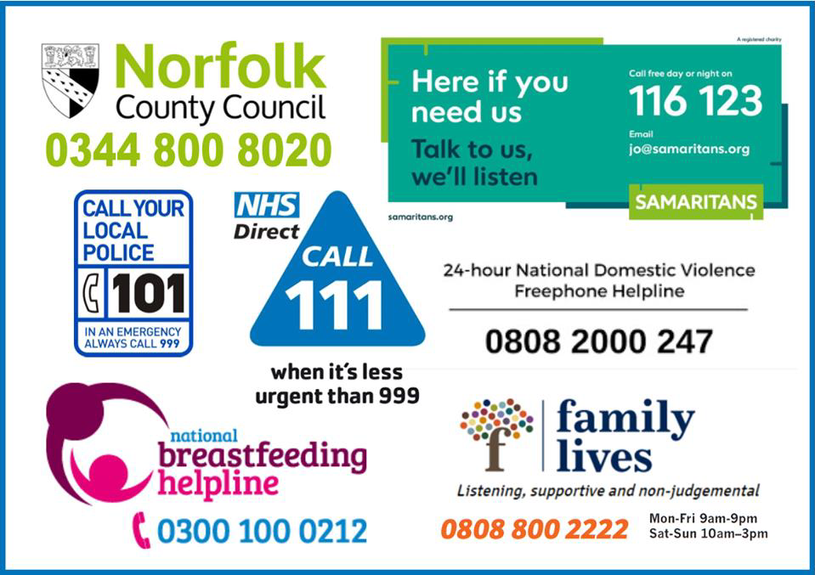

**Update regarding Virtual Socials**  
 Wellbeing have made some changes to make their virtual socials more secure. From now on you’ll have to follow a link via the event’s page on the wellbeing website, where you will find a unique password for each social.

<https://www.wellbeingnands.co.uk/norfolk/take-part/social-events/>

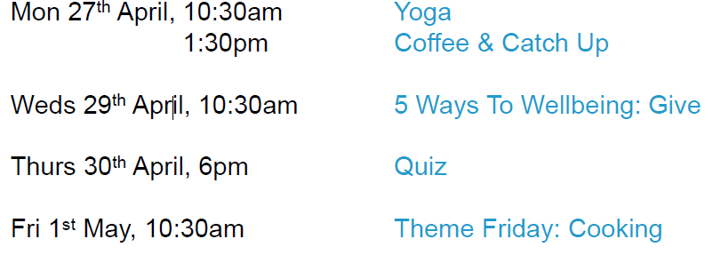They will still add a links to their social media that will bring you to the wellbeing website rather than directly to our virtual socials. Upcoming events:

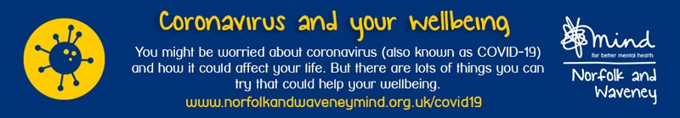

The training team at Norfolk and Waveney Mind have created a guide to Mental Wellbeing during the Coronavirus pandemic. If you wold like a copy of the guide to be emailed to you, please email [cs.cfoteam.nandb@norfolk.gov.uk](mailto:cs.cfoteam.nandb@norfolk.gov.uk). A copy of the guide will be emailed separately to this bulletin.

Online information can be found at:

<http://www.norfolkandwaveneymind.org.uk/coronavirus-and-your-wellbeing>

**Mental Health Support for Children and Young People**

The website, [www.justonenorfolk.nhs.uk/mentalhealth](http://www.justonenorfolk.nhs.uk/mentalhealth) is the primary location to access mental health advice and support for children and young people (aged from 0 – 25 years).  No referral is required.  To visit the site please click the button below.

**[](https://communityactionnorfolk.us2.list-manage.com/track/click?u=c6cf6edba7d2212b75d4841d5&id=89cf0d7905&e=f02efe6a60)**

**Dementia UK**

If you, or someone you know needs advice about dementia, our Helpline Nurses offer practical and emotional support and can be contacted on **0800 888 6678** or by emailing [helpline@dementiauk.org](mailto:emailing%20helpline@dementiauk.org). The Helpline is open seven days a week, 9am-9pm Monday to Friday, and 9am-5pm on weekends

You can sign up to their newsletter and if you’re a Facebook or Twitter user, you’ll be able to get updates from [facebook.com/DementiaUK1](https://dementiauk.us11.list-manage.com/track/click?u=4f2648a6e724e8a89230a5c7d&id=f996829676&e=39745b5feb) and [twitter.com/dementiauk](https://dementiauk.us11.list-manage.com/track/click?u=4f2648a6e724e8a89230a5c7d&id=eb7e7ad18b&e=39745b5feb).

**Domestic Abuse Support Services**

**Dawn’s New Horizon** are still supporting victims of domestic abuse, from the phone, emails, Facebook etc. They are doing food parcels to help people suffering from domestic abuse and families who have fled abuse.

Tel: **0844 884 3140** or Email: [**dawnsnewhorizon@yahoo.com**](mailto:dawnsnewhorizon@yahoo.com)

**Pandora:** (contact online) North Norfolk: [**https://www.pandoraproject.org.uk/**](https://www.pandoraproject.org.uk/)

**Leeway:** Broadland. Tel: **0300 561 0077** or Email: [**referrals@leewaynwa.org.uk**](mailto:referrals@leewaynwa.org.uk)

[**https://www.leewaysupport.org/**](https://www.leewaysupport.org/)

**RESOURCES**

|  |  |  |  |  |  |
| --- | --- | --- | --- | --- | --- |
| |  |  |  | | --- | --- | --- | | |  |  | | --- | --- | | |  | | --- | | **YOUR OWN PLACE - More FREE YouTube Updates**  So we're delighted to say that thanks to funds raised, we will be developing a further five FREE and short videos with the amazing [Rebecca Osborne](https://yourownplace.us6.list-manage.com/track/click?u=142bb523a543fbd4cbc33a251&id=1ea00eef8c&e=b7f9530172).  Update two (2. Covid19 updates - Work & pay) is well underway and being released on our [YouTube Channel](https://yourownplace.us6.list-manage.com/track/click?u=142bb523a543fbd4cbc33a251&id=7be5eb4fa4&e=b7f9530172) this week.     We want to respond to the need YOU are seeing, so please tell us if our plans for the next four are the right ones. | | |  |  |  | | --- | --- | | |  | | --- | | https://mcusercontent.com/142bb523a543fbd4cbc33a251/images/88f49147-0da0-4c01-a900-b5047fd1fd02.png | |   <https://www.youtube.com/watch?v=-WykEpdE2lY&feature=youtu.be> |

|  |  |
| --- | --- |
| |  | | --- | |  | |

**VOLUNTEERING / TRAINING**

**Healthwatch Norfolk**

**Share your experience of accessing information, care and support during COVID-19**

Healthwatch Norfolk are working with local councils, hospitals and other service providers to help them understand the needs of their communities in these challenging times.

The organisation is asking people to share their experience of accessing the right information, support and care by completing a [short survey.](https://www.smartsurvey.co.uk/s/hwncovid19-survey/)

Whether you have had a positive or negative experience since the COVID-19 outbreak, it is important that you share your thoughts so that providers know what is working well and what could be improved.

You can complete the survey by visiting the [Healthwatch Norfolk website](https://healthwatchnorfolk.co.uk/hwn-covid-19-survey/), or by contacting them on 01953 856029, where you will be able to complete the survey on the phone with a member of their engagement team.

The survey is an opportunity for you to have your say about anything relating to care and support since the outbreak of the virus, but Healthwatch Norfolk are particularly interested in hearing about:

– Quality of local information and advice about coronavirus

– Your experience of urgent and emergency care

– Experience of health and social care routine appointments

– Communication from NHS trusts, councils and charities

– Managing your mental and physical health at home

– Advice for individuals and families in self-isolation

– Caring for someone in isolation

– Access to dentistry services in Norfolk

– Positive experiences and messages of support for health and social care staff



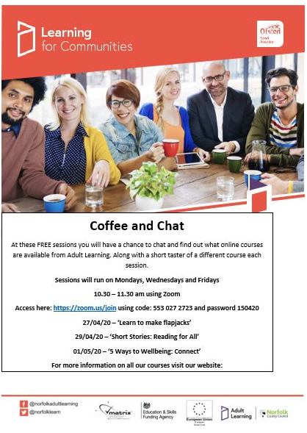

The information provided in our bulletins is sent to us from various sources.  We try to ensure the information is correct at the time of publication but there may be some inadvertent errors.  Publication in our bulletin does not necessarily constitute an endorsement of a service / organisation and we would advise you to take reasonable steps to check the services offered and organisation prior to using them – especially if you are referring children, young people and vulnerable adults to a service. Norfolk County Council cannot accept any liability for any services provided by a third party.