Frettenham Primary School Greater Depth examples

Year 3

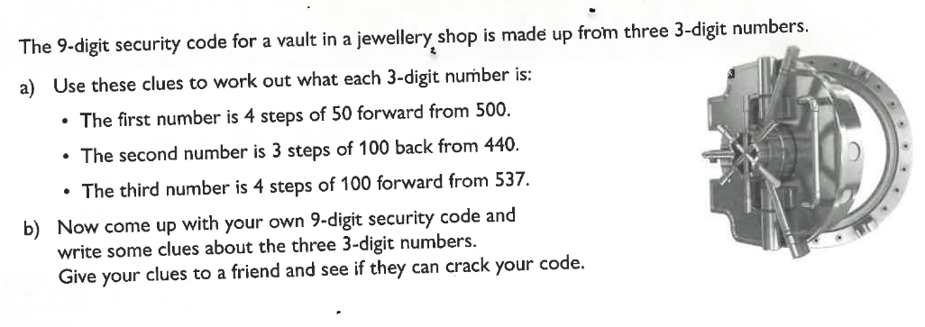

Year 4

Year 5

Year 6

