Hainford Primary School
Reading Project
The Tin Forest – Helen Ward
In Class 1 our Reception and Year 1 children created their own Class Tin Forest and wrote lists about what animals they could see. | 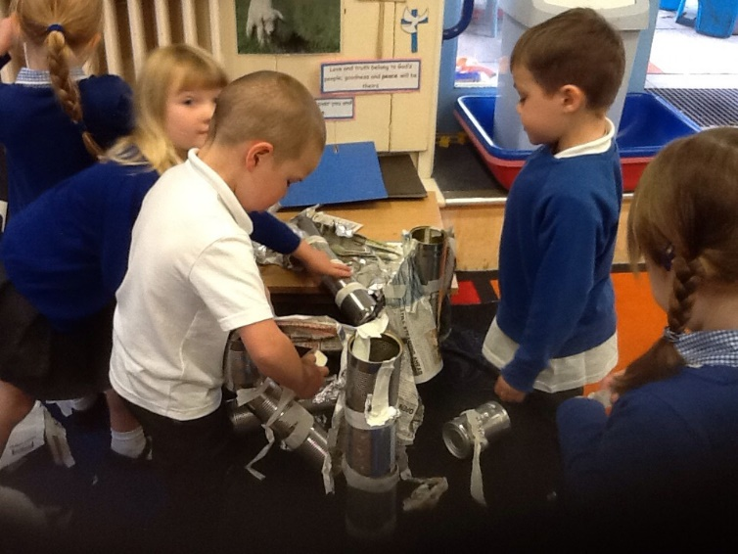
In Class 2 our Year 2 and Year 3 children learnt an adapted version of the story by heart using actions and words. They performed it to school
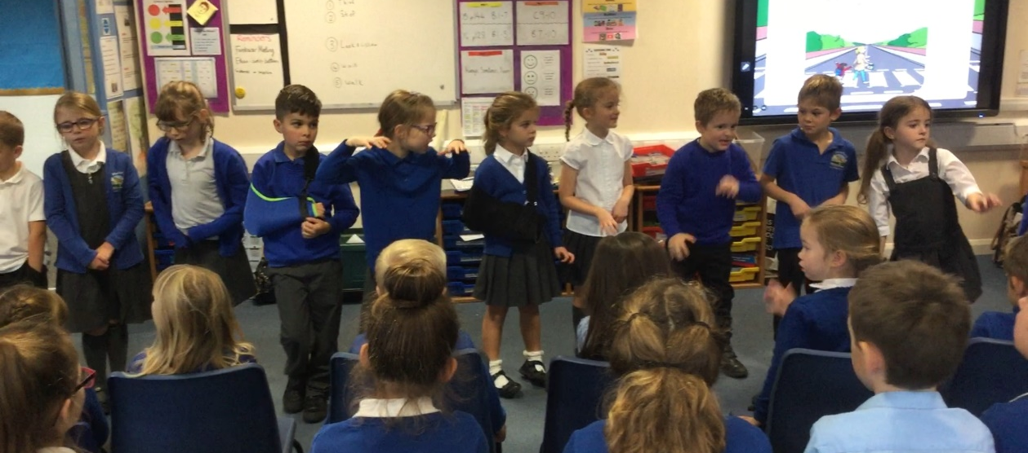

The Promise - Nicola Davies
In Class 3 our Year 4, 5 and 6 children wrote poems, setting descriptions and newspaper reports based on the book ‘The Promise’. | 