**Class 1**

**Easter Learning Tasks**

As the Easter period approaches, I know it will be time for a welcome break for you all.

However, as this time of uncertainty continues and we are not allowed to get out and about as much as we would like, you may find yourself at a loose end and be looking for some suggestions.

I’ve put together a new list of activities that the children may want to have a go at to keep them entertained over the next couple of weeks.

I will pick up any messages that are sent on Tapestry as usual so please feel free to ask for any information or request anything else you might want or need for at home.

Have a restful Easter break and enjoy the time with your families.

Stay safe and well,

Stacey

**Easter Story:**

Watch an animated version of the story here:

<https://www.bbc.co.uk/teach/class-clips-video/religious-studies-ks1-the-christian-story-of-easter/zhgv47h>

**R.E. Quest-** Animated stories and Easter learning activities, as well as an ‘Easter Home Learning Pack’:

<https://request.org.uk/restart/2020/03/24/easter-home-learning-pack/>

**Attached Resources:** (Scroll down to see)

Make an Easter Boardgame P.2

The Easter Bunny’s Baskets Pp.3-4

Repeating Pattern Easter Eggs P.5

Easter Maths Problems 1 P.6

Easter Maths Problems 2 P.7

Easter Maths Problems 3 P.8

Easter Maths Problems 4 P.9

Help the Bunny! P.10

**\*\*\*As well as these, there are LOADS of fun craft, cooking and puzzles activities to be found online. Just type Easter activities into Google.**

**Make an Easter Game!**

*Your mission is to make a mathematical board game for children to play.*

*Your game should include an Easter theme and a set of instructions.*

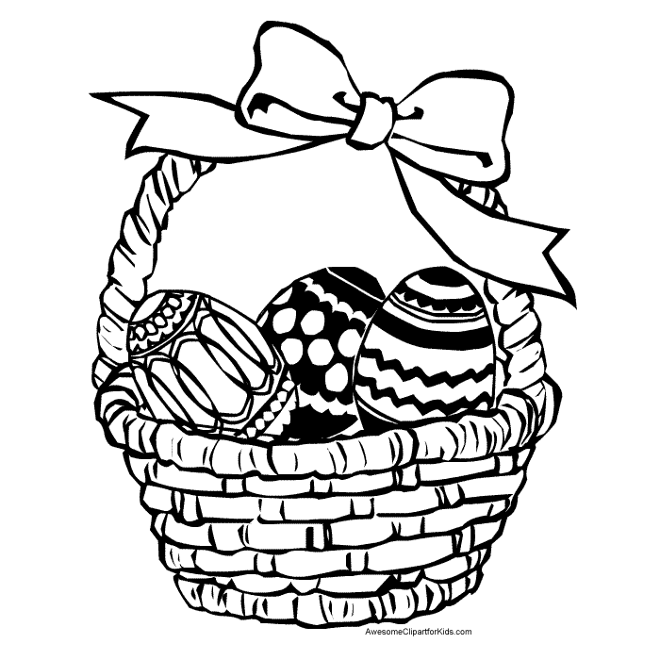

Ask yourself these questions when planning your game:

* How am I going to include maths in my game?
* How will the players move around the board?
* Should there be extra tasks to complete such as activities on cards?
* Do I need to make counters?
* Do I need to make dice using the net of a cube?
* How am I going to keep all the items needed for the game together?

Good Luck and Happy Easter

**The Easter Bunny’s Baskets**

The Easter bunny has lots of red, blue and green Easter eggs. He can only fit 3 eggs in each of his baskets. How many different egg baskets can he make? He can use more than one egg of the same colour.

|  |  |  |  |
| --- | --- | --- | --- |
| http://milliande.smugmug.com/photos/494688845_sfGRH-X3.jpg | http://milliande.smugmug.com/photos/494688845_sfGRH-X3.jpg | http://milliande.smugmug.com/photos/494688845_sfGRH-X3.jpg | http://milliande.smugmug.com/photos/494688845_sfGRH-X3.jpg |
| http://milliande.smugmug.com/photos/494688845_sfGRH-X3.jpg | http://milliande.smugmug.com/photos/494688845_sfGRH-X3.jpg | http://milliande.smugmug.com/photos/494688845_sfGRH-X3.jpg | http://milliande.smugmug.com/photos/494688845_sfGRH-X3.jpg |
| http://milliande.smugmug.com/photos/494688845_sfGRH-X3.jpg | http://milliande.smugmug.com/photos/494688845_sfGRH-X3.jpg | http://milliande.smugmug.com/photos/494688845_sfGRH-X3.jpg | http://milliande.smugmug.com/photos/494688845_sfGRH-X3.jpg |

|  |  |  |  |
| --- | --- | --- | --- |
| http://milliande.smugmug.com/photos/494688845_sfGRH-X3.jpg | http://milliande.smugmug.com/photos/494688845_sfGRH-X3.jpg | http://milliande.smugmug.com/photos/494688845_sfGRH-X3.jpg | http://milliande.smugmug.com/photos/494688845_sfGRH-X3.jpg |
| http://milliande.smugmug.com/photos/494688845_sfGRH-X3.jpg | http://milliande.smugmug.com/photos/494688845_sfGRH-X3.jpg | http://milliande.smugmug.com/photos/494688845_sfGRH-X3.jpg | http://milliande.smugmug.com/photos/494688845_sfGRH-X3.jpg |
| http://milliande.smugmug.com/photos/494688845_sfGRH-X3.jpg | http://milliande.smugmug.com/photos/494688845_sfGRH-X3.jpg | http://milliande.smugmug.com/photos/494688845_sfGRH-X3.jpg | http://milliande.smugmug.com/photos/494688845_sfGRH-X3.jpg |
| http://milliande.smugmug.com/photos/494688845_sfGRH-X3.jpg | http://milliande.smugmug.com/photos/494688845_sfGRH-X3.jpg | http://milliande.smugmug.com/photos/494688845_sfGRH-X3.jpg | http://milliande.smugmug.com/photos/494688845_sfGRH-X3.jpg |
| http://milliande.smugmug.com/photos/494688845_sfGRH-X3.jpg | http://milliande.smugmug.com/photos/494688845_sfGRH-X3.jpg | http://milliande.smugmug.com/photos/494688845_sfGRH-X3.jpg | http://milliande.smugmug.com/photos/494688845_sfGRH-X3.jpg |

**Repeating Pattern Easter Eggs**

Decorate these eggs using repeating patterns

**Easter Maths Problems 1**

The Easter Bunny has 10 eggs in his basket. 3 fell out on the way to the ‘Great Egg Hunt’. How many does the Easter Bunny have now?

The Easter Bunny has 8 eggs in his basket. It then puts 5 more in his basket. How many does the Easter Bunny have now?

The Easter Bunny wants to put each of his eggs in a box, which cost 10p. It has 6 eggs. How much will it need to spend?

The Easter Bunny has 5 boxes that it needs to fill equally with his 10 eggs. How many eggs will go in each box?

The Easter Bunny buys an Easter egg for 11p and an Easter card for 27p. How much did it spend?

The Easter Bunny starts off with 20 eggs in his basket. At the first house it drops off 7 eggs, and at the second house it drops off 5. How many eggs are in his basket now?



**Easter Maths Problems 2**

The Easter Bunny has 27 eggs in his basket. 13 fell out on the way to the ‘Great Egg Hunt’. How many does the Easter Bunny have now?

The Easter Bunny has 43 eggs in his basket. It then puts 24 more in his basket. How many does the Easter Bunny have now?

The Easter Bunny wants to put each of his eggs in a box, which cost 15p. It has 6 eggs. How much will it need to spend?

The Easter Bunny has 5 boxes that it needs to fill equally with his 20 eggs. How many eggs will go in each box?

The Easter Bunny buys an Easter egg for 45p and an Easter card for 26p. It pays with a £1 coin. What change does it get?

The Easter Bunny starts off with 50 eggs in his basket. At the first house it drops off 20 eggs, and at the second house it drops off 13. How many eggs are in his basket now?

**Easter Maths Problems 3**

The Easter Bunny has 43 eggs in his basket. 15 fell out on the way to the ‘Great Egg Hunt’. How many does the Easter Bunny have now?

The Easter Bunny has 43 eggs in his basket. It then puts 28 more in his basket. How many does the Easter Bunny have now?

The Easter Bunny wants to put each of his eggs in a box, which cost 25p. It has 6 eggs. How much will it need to spend?

The Easter Bunny has 5 boxes that it needs to fill equally with his 40 eggs. How many eggs will go in each box?

The Easter Bunny buys a new basket for £1.45 and an Easter card for 27p. It pays with a £2 coin. What change does it get?

The Easter Bunny starts off with 50 eggs in his basket. At the first house it drops off 27 eggs, and at the second house it drops off 15. How many eggs are in his basket now?



**Easter Maths Problems 4**

The Easter Bunny has 103 eggs in his basket. 47 fell out on the way to the ‘Great Egg Hunt’. How many does the Easter Bunny have now?

The Easter Bunny has 243 eggs in his basket. It then puts 128 more in his basket. How many does the Easter Bunny have now?

The Easter Bunny wants to put each of his eggs in a box, which cost 25p. It has 8 eggs. How much will it need to spend?

The Easter Bunny has 5 boxes that it needs to fill equally with his 75 eggs. How many eggs will go in each box?

The Easter Bunny buys a new basket for £1.45 and a pack of Easter card for £2.27. It pays with a £5 note. What change does it get?

The Easter Bunny starts off with 50 eggs in his basket. At the first house it drops off 27 eggs, and at the second house it drops off 15. He then decides he doesn’t have enough so buys another 33. How many eggs are in his basket now?

Help the Bunny!

The Easter Bunny has lost all his eggs! Can you help him find them? Draw them on the grid in the correct places. You will have to label the axes of the grid as well.

|  |  |  |  |  |  |  |  |
| --- | --- | --- | --- | --- | --- | --- | --- |
|  |  |  |  |  |  |  |  |
|  |  |  |  |  |  |  |  |
|  |  |  |  |  |  |  |  |
|  |  |  |  |  |  |  |  |
|  |  |  |  |  |  |  |  |
|  |  |  |  |  |  |  |  |
|  |  |  |  |  |  |  |  |
|  |  |  |  |  |  |  |  |

Eggs can be found at:

(1,1) (2,2) (3,3) (4,4) (5,5) (6,6) (1,3) (1,6) (2,4) (3,1) (3,5) (4,6) (4,1) (5,2) (5,1) (5,3) (6,1) (6,4) (6,5)