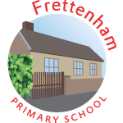

**Class: 3**

**Term:Sum2**

**Global**

**Eye**

**Spelling**

Prefixes

Adverbials

Word endings

**Languages**

Spanish:

family, sizes, around the house

**Visit/Visitor**

Whitwell

Visual journalism

Hieroglyphics

Masks

Props

Water

**Maths**

Fractions decimal and percentages

Solving problems using all operations and measures.

Water cycle

Reversible

changes

**Art/DT**

**Science**

**Geography**

Egypt

River Nile

Map work

Pyramids

**Guided Reading**

Aquila

Cosmic

Wonder

**English**

World cup research

Report writing

**PE**

Athletics

Rounders

Egyptian music

Instruments

**Music**

**Computing**

E-Safety

**PATHs –** SRE and values

**RE –** Christianity: gospel