

Hainford VC Church of England Primary School
New Reception Welcome Pack 2026
Welcome
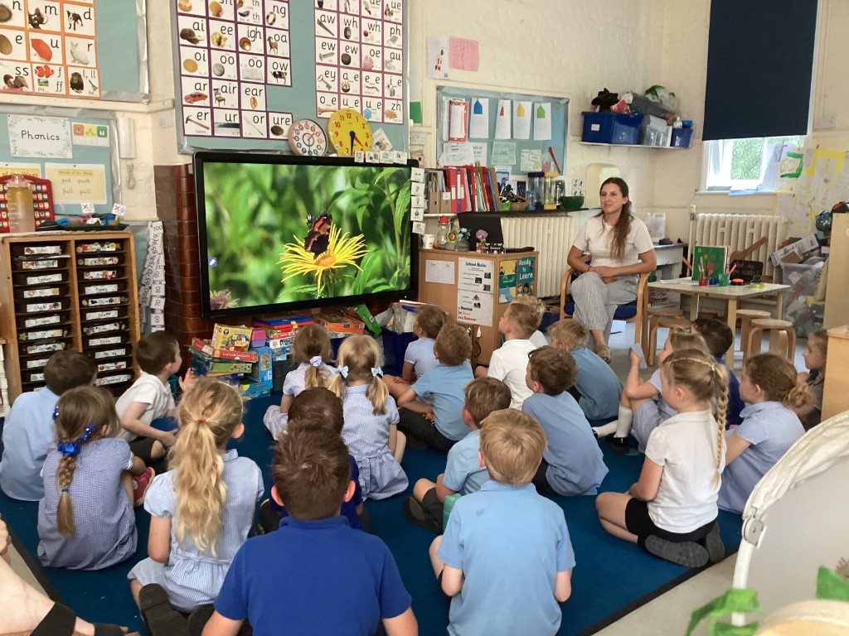



Welcome
Welcome to Hainford VC Church of England Primary School and to Class 1.
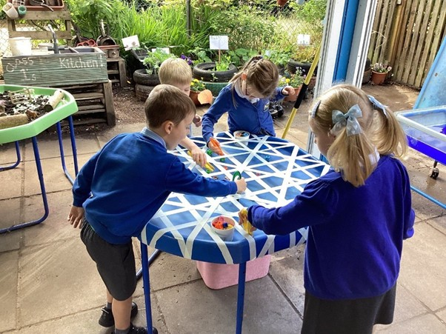
From the very start of their school life, children at our school are encouraged to be independent. The classroom allows children opportunities to make choices and decisions in a safe environment with adult support and encouragement.
The school gates open at 8:30am and a member of staff will be there to greet them until 8:45am. At this time, parents are encouraged to say goodbye and children come into the classroom to put away their coats and book bags independently.

Throughout the day, the children access all the areas of the curriculum through both adult-directed and independent activities. The school day begins with a whole-class registration and introduction to the day’s activities. The rest of the day consists of a mixture of time for the children to develop their learning, either individually, within a small group, with a teacher or as a whole class. The children are encouraged to develop their learning independently through play, both indoors and outdoors.

Each day, the children will take part in short carpet sessions focusing on maths, phonics skills for reading and writing and learning from across the curriculum. Activities within the provision then give children the opportunity to use and apply this learning through their play. At the end of the day, the children are brought together for a short circle time, song, and a story before they go home.

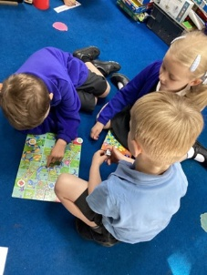
At lunch time, the children can choose between having a hot dinner or a packed lunch brought from home. When the children have finished their lunch, they will join the rest of the school on the field or playground. This gives them the opportunity to mix with other children and experience a range of play equipment and games.

At home time, parents wait on the playground outside Class 1 and children will be dismissed at 3:00pm when the teacher can see the parent (or collecting adult) has arrived.

What should you expect in your child’s first week at school?
The most important thing you must remember during your child’s first week at school is that there are other children and their parents going through the same experience. This is a big step in your child’s development and a significant shift in their routine. We understand that every parent worries about their child’s first week at school. It is our aim to support you and your child as much as we possibly can during this time and in the future.

Below are some tips that will help you to support your child during their first week at school:
- Have a morning routine at home.
- Get to school promptly.
- Reassure them that they will have lots of fun!
- Tell them that all the parents/ carers must go home.
- Say goodbye quickly and reassure them that they will have a good day.

If your child holds on to you, please allow their teacher or teaching assistant to support them into coming into school.

What will your child need to bring to school?

We take pride in our uniform. All items can be purchased from My clothing: https://myclothing.com/
Please ensure ALL items of clothing are named, even coats and shoes!

Weather-appropriate clothing
Children love to learn outside whatever the weather, so it is advisable that children always have a light waterproof coat and a sun hat in school to ensure that they are always prepared, along with a change of clothes for emergencies.
If your child has waterproof clothing and wellies in school, it will enable them to make the most of these opportunities.

P.E. Kit
On PE days children come into school in their PE kit and stay in their kit all day which includes black shorts, a white or blue t-shirt and trainers/ outdoor shoes. A jumper and jogging bottoms can also be provided in the winter months. Spare clothes (socks, pants, trouser/ skirt, t-shirt) can also be placed in a bag.

Book bag
Your child will be provided with a book bag by Hainford PTA. Keep this and any other schoolbooks in this bag so that your child can access these in school. Any letters from school will also be placed in here.

Hot Dinners/ Packed Lunch
School meals are available for free every day. A menu for the term is provided in the Welcome Pack and is available online. Your child may have a school dinner every day or may choose to eat when their favourite food features on the menu.
Some children choose to have a packed lunch- parents sometimes find this an easier way to monitor how much their child is eating and know they can provide some of their child’s favourite foods. Please ensure that lunchboxes are named!

Water Bottle
Fruit snacks and water are available at break time, but we do advise that children bring their own named water bottle that they can access at any time. This should contain only water if it is to be drunk in the classroom.

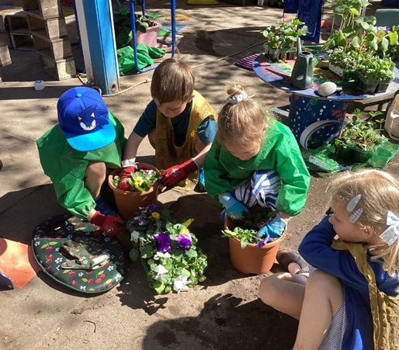

The Curriculum
Throughout their time in school, the children learn a wide range of skills. Learning activities are planned in line with the Early Years Foundation Stage curriculum.

The curriculum is split into seven main areas of learning. These are:
Personal, Social and Emotional Development
Talking about personal experiences, getting to know ourselves and the people around us. An introduction to Religion and Religious festivals.

Communication and Language
Speaking and listening skills, understanding of language.

Literacy
Letter recognition, reading, writing, letter formation, pencil control, knowledge of books.

Mathematics
Number, counting, shape, pattern, money, measure and estimation.

Understanding the World
Life processes, understanding of living things and how to care for them, our environment, life in the past, designing and constructing and using ICT in everyday life.

Physical Development
Understanding how the body develops and changes, ball skills, balancing, following instructions, sequencing activities and controlling movements.

Expressive Arts and Design
Pencil control, drawing, pattern, colour, paint, colour mixing, using powder paints, texture, collage, 3D construction and modelling, music and role-play.

The Foundation Stage Profile

The Foundation Stage Profile focuses on your child’s achievements in the seven areas of learning. In order to keep track of what your child has achieved during the year, we will make observations, take photos and keep notes on what they are doing. When your child has achieved something in one of the seven areas of learning, we will record their achievements on ‘Tapestry’- an online learning journal. Each child is taught according to their own interest and needs. All children are individual and we recognise that they each have their own strengths and areas for development. By keeping a record of what your child is achieving, we are able to focus our teaching to your child’s individual next steps. It is our aim to ensure that they get exactly what they need to enthuse, encourage and move them on.

Whole School Routines

Collective Worship and Assemblies
Reception children will sometimes take part in whole-school acts of Collective Worship and assemblies. Every Friday, the school comes together to celebrate the achievements of the children both inside and outside of school.

Assertive Mentoring / Parent Meetings
Teachers are available and happy to speak with parents after school most days. If you have something that you would like to discuss with them, please make an informal appointment. During the year, there are three formal occasions where you can meet with your child’s teacher to find out how your child is progressing and how you can support them at home. Towards the end of the summer term, teachers and parents will meet to discuss your child’s end of year report which records their progress and achievements for the year.

Class Routines

P.E.
Your child will take part in regular P.E. sessions. Please ensure that your child wears their P.E. kit on these days. These sessions will take place twice per week.
Throughout the year, your child will have opportunities to develop their skills in listening and team games, throwing and catching, gymnastics and dance.

Playtimes
Playtime each morning is at 10:45am to 11:00am.
This is a time for the children to socialise with their classmates and the children across the rest of the school, eat a healthy snack and take in some fresh air.
Playtimes are also an opportunity for children to go to the toilet. These facilities are available throughout the day and children are encouraged to go as and when they need to.

Reading Books
Children must bring their reading book to school every day. Staff will aim to change reading books at least once a week.

Supporting Your Child
Throughout their time at school, the teacher will work hard to ensure that your child makes the most of every opportunity they are given to make progress. It is important that this is reflected at home through the valuable support parents and carers provide.
We aim to provide many opportunities for parents to come into school to find out what the children are doing. Each week, we send home information about our topic with ideas for parents to help support their child’s learning at home.

Reading and Key Words
Each child is given a reading diary to keep in their book bag. Parents are encouraged to write positive comments in this book when they listen to their child read. Teachers and Teaching Assistants will also do this when they hear your child read.
Throughout the year, your child will bring home a bag of word cards. These words will be added to as the children encounter more words in their phonics learning.

