St Faiths’ Church of England Primary School

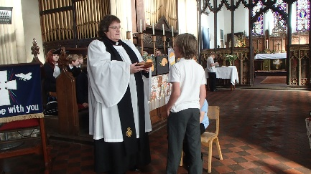
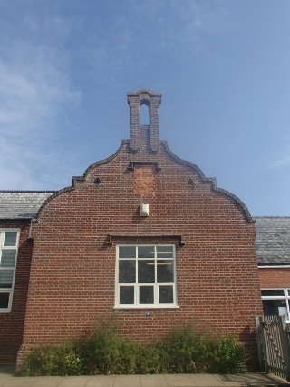
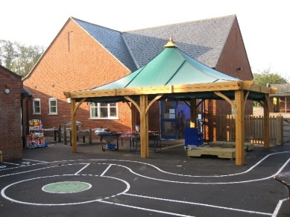
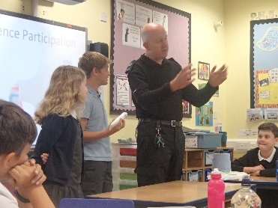
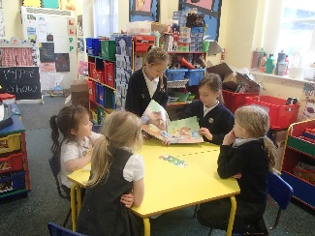
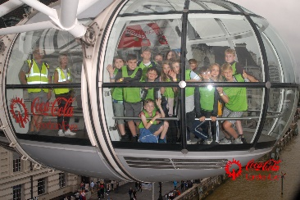
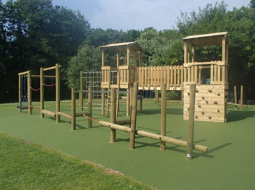
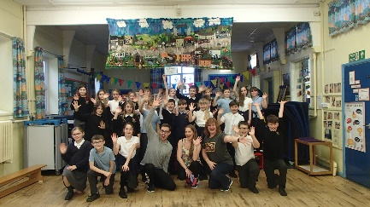
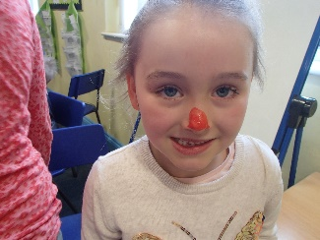

School Prospectus
2021 – 2022

A snapshot of our school for parents, carers
and prospective pupils

Contents Page

Page 3 |  | A Warm Welcome
Page 4 |  | Christian Values
Page 5 |  | About our School
Page 6 |  | Staffing
Page 7 |  | Nebula Federation
Page 8 |  | School Timings and Routines
Page 9 |  | School Uniform
Page 10 |  | Meals and Snacks
Page 11 |  | Our Curriculum
Page 13 |  | Communication
Page 14 |  | Special Educational Needs and Disabilities
Page 15 |  | Equipment
Page 16 |  | Behaviour
Page 18 |  | Attendance
Page 19 |  | Safeguarding
Page 20 |  | Health and Safety
Page 21 |  | Admissions
Page 22 |  | Complaints Procedure

Welcome from the Senior Leadership Team

Dear Parents and Carers,

We’d like to wish you a warm welcome to our school. We’re a thriving Church of England village school, offering a good education to children in the community. We pride ourselves on our “caring, inclusive school” (Ofsted, Feb 2019) and work hard to create an environment that allows our children to thrive and flourish. Being a village school, we know our children well and tailor our learning experiences to their interests and learning styles. You’ll see from our prospectus many of the wonderful things we do, but should you want to find out more, please get in touch or visit our website.

~ Mrs J Porter and Miss K Wilson

Hello from the House Team Captains
In our school, we have four house teams. We are in charge of Circle Time which is usually held on Thursdays. In Circle Time we talk about how we could make the school even better. We are role models to the other children in school and lead different activities throughout the year including Buddies, Christmas crafts and Sports Day.
We hope you like our school!

School Contact Information

St Faiths’ Church of England VC Primary School
Manor Road
Horsham St Faith
Norwich
Norfolk
NR10 3LF
Tel: 01603 898353
Email: office@stfaithsprimary.norfolk.sch.uk
Website Address: http://www.harnserfed.co.uk/

Christian Values

St Faiths’ C of E Primary School is a Voluntary Controlled Church of England School. This means that, in addition to teaching Religious Education in accordance with the Norfolk Agreed Syllabus for Religious Education, we have to ensure that our school has a distinctively Christian ethos.
In our school:
- We celebrate everyone’s God-given talents in day-to-day school life with positive praise, sticker rewards, house points and class celebrations.
- We regularly select individual children for recognition in our weekly Celebration Assembly.
- We offer the opportunity for everyone in our school community to reflect on Christian values in our daily act of collective worship.
- There are quiet yet stimulating areas throughout for individual thought and small discussion.
- We help our children to become familiar with Anglican traditions and biblical stories.
- Our Reverend also comes to lead a collective worship once a week.
- We offer the opportunity for children to engage in and lead prayer daily. Children pray before lunch, going home and during worship time. Children are encouraged to write their own payers for the prayer box which are shared during collective worship.
- Our behaviour policy is based upon the Christian values of truthfulness, kindness, respect and forgiveness.
- We encourage everyone in our school to be forgiving and to be the best they can be.

Our School’s Core Christian Values
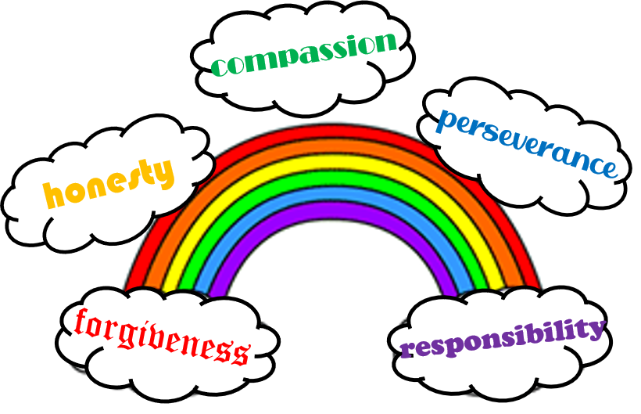

About our School

A Brief History
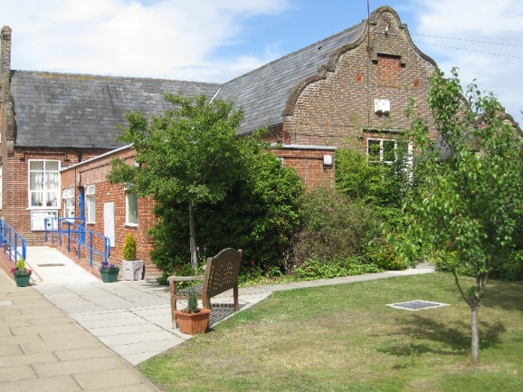
Our school was built in 1853 by the Twining family – most notable for their famous tea empire. Richard Twining attended Norwich Grammar School and at 15 years of age was sent to London to study business in The Strand. He would continue to visit St. Faiths occasionally and it was his wish that the children of the village should have a good school.
At the age of eighty, his children, grand-children and other relatives contributed to the building of our school. Sadly, Richard Twining died just five years later. Upon his death he left the vicar and churchwardens the sum of £450 to support the school and £180 to provide coal for the poor during the winter months.
Having become a primary school in 2007, we federated with Hainford and Frettenham Primary Schools to become the Harnser Federation in 2016, before joining with 3 other local schools that now make up the Nebula Federation.

Classroom Organisation
For the academic year 2021-2022 we have around 100 children on roll, organised into 4 classes:

Elm Class
Reception and Year 1 children are taught by Miss Cunningham.
Chestnut Class
Year 2 and Year 3 children are taught by Miss Woolley.
Oak Class
Year 4 and Year 5 children are taught in by Miss Bean.
Willow Class
Year 6 children are taught by Miss Wilson.

Staffing

Executive Team
Executive Headteacher
Mrs A Best-White
Executive Deputies for  School Improvement  Mrs K Connelly  Mrs N Pellatt | Executive Deputy for SEND  Mrs J Porter | Executive Deputy for EYFS  Ms K Anatola

Teaching Staff
Senior Leadership Team
Mrs J Porter
Miss K Wilson
Reception/Year 1  Miss S Cunningham | Year 2/Year 3  Miss C Woolley |  | Year 4/Year 5  Miss E Bean |  | Year 6  Miss K Wilson
SENCo  Mrs M Board |  | PE Teachers  Mrs L Hudson  Mrs A Mooney |  | Science Teacher  Mrs F Nerney

Classroom Support Staff
Mrs C Bolton  Miss P Harker  Mrs A Hopkins  Mrs L Palmer | Mrs S Weston  Mr A Wickham  Mrs S Youngs
PE Apprentice
Miss J Newton

Site Staff
School Secretary | Mrs S Jeffery
Caretaker/Cleaner | Mrs M Warner

Lunchtime Staff
Dining Room Assistant | Mrs T Gowen
Midday Supervisor | Mrs G Middleton

Nebula Federation

We are a federation of six schools in the north of Norwich.

We are a mix of community and church schools, primary and junior schools, mixed-age and single-age classes and larger than and smaller than average schools!

We recognise and celebrate the individuality of each school and promote the Christian ethos of our church schools. What all our six schools have in common however, is that they work closely together, to share their strengths and address areas of improvement to ensure that collectively they are providing the very best education for our children. The federation means we can highlight what works in each of our schools and have wider collective support to overcome some of the challenges that schools can face.

The core purpose of the federation is to develop the very best, self-improving organisations to ensure that our children do exceptionally well and are prepared for the future. We are committed to provide each and every child with holistic education that enables them to be successful and discover their talents.

Our enthusiastic and creative staff have a vast range of skills and experience in meeting learners’ needs. We work hard to nurture the hidden potential we believe is in every child, giving them a range of experiences and the best possible opportunity to succeed. We are proud of our staff and what we are able to provide for our pupils and the wider community. The skills and qualities of our staff are key to this success.

~ Mrs A Best-White

Governors
A body consisting of people drawn from the community, parents and teachers governs the school. School governors have important responsibilities which are laid down in the Articles of Government. We have a federated governing body which is responsible for supporting the schools in our federation.

Chair of Governors
Sue Hill

More information about our governing body can be found here:

http://www.harnserfed.co.uk/home/governors/

School Timings and Routines

The School Day
8:45am The school gate open
8:55am Registration
9:00am Morning Session 1
11:00am Break Time
11:15am Morning Session 2
12:15pm Lunch Time
1:10pm Registration
1:15pm Collective Worship
1:30pm Afternoon Sessions
3:10pm End-of-Day: Reception and Years 1-3
3:20pm End-of-Day: Years 4-6

Morning Routine
At 8:45am, the school gate is opened by a member of staff. They wait at the gate until 8:55am and offer the school deposit box for any office correspondence or messages for class teachers. Parents are asked to leave their children at the gate to walk into class and begin their early-morning routines.

We understand that this may be daunting for new children, so we allow parents of children new to the school to take their children to class until the children feel confident to come in independently. This is usually by the end of the Autumn Term.

After-School Routine
The gate is opened at 3:05pm and parents are invited to wait for children from Reception and Year 1, and Years 2 and 3 near their classroom doors. Once these children are collected, we ask parents to leave the school ground and wait for the older children between the first and second gates. Children in Year 4 to 6 leave class independently. You may wish for your child – when they are in Key Stage 2 – to walk home independently. Any decision should be indicated to the class teacher or in writing. If a child expects an adult to be waiting and there is nobody there, they should come back into school so a member of staff can call their responsible adult.

Term Dates
We follow the Norfolk County Council agreed term date calendar.

This can be found at:
https://www.norfolk.gov.uk/education-and-learning/schools/term-dates-and-school-holidays
School Uniform

Winter | 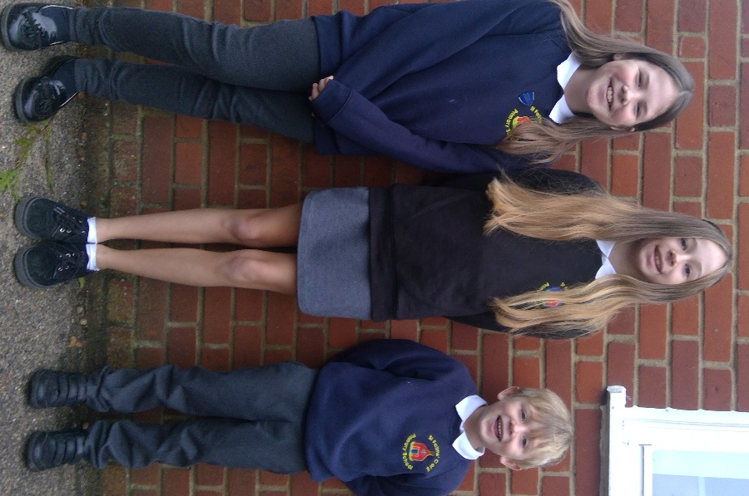 |  | Summer
- Black or grey trousers  - Black or grey skirt/pinafore dress  - White shirt or polo shirt  - Navy sweatshirt or cardigan  - Black shoes  - Change of footwear for outdoor use at lunchtime  - EYFS/KS1 – School book bag  - KS2 – School bag |  |  | - Black or grey shorts  - Blue gingham dress  - White shirt or polo shirt  - Black shoes  - Navy sweatshirt or cardigan  - EYFS/KS1 – School book bag  - KS2 – School bag
PE Kit (All Pupils)  - Plimsolls or trainers  - White t-shirt  - Plain blue/black shorts  - Hoodies/joggers permitted for winter games |  | Swimming Kit (Key Stage 2)  - Swimming trunks or one-piece costume  - Swimming hat  - Towel  - Goggles (with written permission)

We ask that PE kits stay in school all week as the timing of PE lessons may change due to inclement weather.

Year 6
Children in Year 6 are given a black school sweatshirt. We expect the Year 6 children to wear black as it helps make them identifiable in school and gives them additional responsibilities as positive role models to the younger children.

Purchasing School Wear
Items of school uniform and book bags branded with our school logo are available from Birds of Dereham or www.myclothing.com.

Meals and Snacks

School Lunches
Home school dinners are cooked by Norse to comply with the Government’s Nutritional Standards. They work on a 3-week rotation and we have vegetarian and jacket potato options daily. Special meal events are held throughout the year to encourage children to try different meals or celebrate national events.

We encourage all Infant children to have a hot meal each day as they are entitled to a Universal Free School Meal. For children in Key Stage 2, the cost of school dinner – with dessert – is £2.30. Older children tend to pay for their meals on a Monday for the week ahead. This is done through the school deposit box. We are unable to offer change, but an account can be in credit for future meals.

Packed Lunches
You may prefer to send your child to school with a packed lunch. This should be brought to school in a named, reusable container. To help support our ‘Healthy School’ approach, we ask that chocolate and sweets are not included in a packed lunch.

Break Time Snack
Healthy snacks such as fresh fruit, raw vegetables, cheese or dried fruit may be eaten at break time. Under the Government’s National Fruit and Vegetable Scheme, children in Reception, Year 1 and Year 2 classes receive a daily piece of fruit or vegetable.

* Please note: we are a nut-free school. *
This includes Nutella-style spreads in sandwiches.
Water
We recommend each child has their own named water bottle that they can use in class. We have one water fountain in school and drinking water in class so these can be regularly refilled as necessary.

Our Curriculum

At St Faiths’ Primary School, we follow the National Curriculum. Our curriculum also contains a variety of enriching activities and opportunities, which supplement and extend the objectives of the National Curriculum.

With having mixed-age classes, it is important that we ensure all areas of the curriculum are planned for and taught. Each class has a long-term plan in place and termly overviews are sent out to parents (as well as being available online).

The following subjects are taught in school:

Core Subjects
English | Maths | Science

Foundation Subjects
Design and Technology | Art and Design | History | Computing
Geography | Let’s Think in English | Music | Physical Education
French/Spanish | Religious Education | Relationship and Sex Education | Personal, Social and Health Education
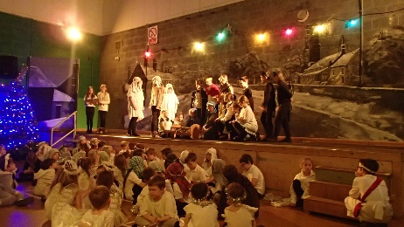
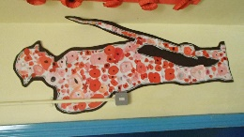
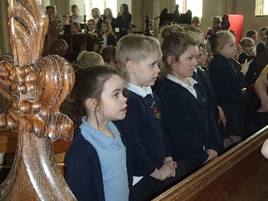
Religious Education
At St Faiths’ Primary School, we follow the Norfolk Agreed RE syllabus. We have discrete RE lessons each week as well as learning through other areas of the curriculum or experience days/events.

Collective Worship
In deciding that the daily assembly should consist of hymns, stories and prayers, and be broadly Christian in content, we ensure that Collective Worship is:
- an activity where all can contribute, and all can gain
- "collective" not "corporate"
- meaningful: seen as part of the whole school curriculum
- an "intentional learning experience"
- focused on what goes on in the school, sharing pupils' work and achievements.
Curriculum Enrichment
Being part of the Nebula Federation has allowed our children to participate in a wide range of enrichment activities. Every year children get the opportunity to participate in Charley Charley 1’s Challenger Bronze Award. This award is designed to engage younger pupils in exciting learning experiences, challenges and community projects that prepare them for future learning. We have also been involved in:
- The Shakespeare School Festival
- The Goblin Racing Car Project
- Young Voices at the O2 Arena
- Author visits from Luke Temple and Karl Nova

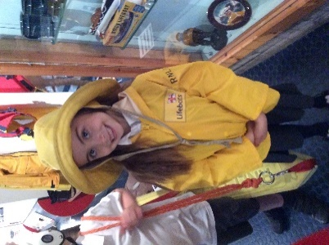
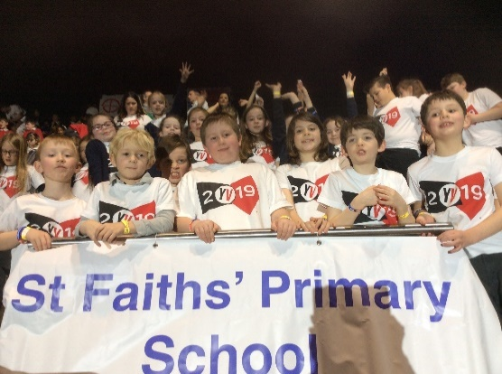
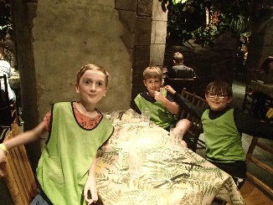
Educational Visits
As part of our extended provision, we plan for a variety of school trips to enhance the children’s learning in school. Day trips we offer include visits to Norwich Castle and Gressenhall Museum, along with visits further afield including London and Chessington World of Adventures.

We also offer biennial residential visits for children in Key Stage 2. These visits take place with our friends and colleagues at Frettenham and Hainford to offer children a broader and more social experience with friends they make through other federation activities. Recent residentials have included Whitwell Hall and Norfolk Lakes.

Extra-Curricular Activities
At St Faiths’ we pride ourselves on offering a wide variety of after-school and lunchtime clubs for children throughout the school. Recent clubs offered include:

 | - Lego Club  - Banagrams Club  - Enterprise Club  - Yoga  - Football Club  - Tag Rugby Club  - Premier Dance Club | 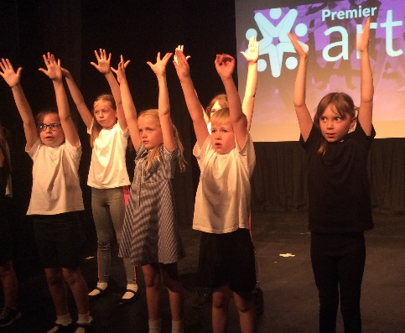
We are always open to suggestions for new clubs and try to offer a broad range each term. Children are invited to share their ideas during our Circle Time meetings.

Communication

Newsletter
A fortnightly newsletter is sent out to keep you informed of school news and events. The newsletter is emailed out to ensure that parents/carers will see the newsletter as soon as it is issued. If you are unable to receive our newsletter electronically, please speak to the office. Paper copies are also available from the office foyer.

Email
We use Pupil Asset to communicate our emails. This is an electronic messaging service and is the main way we communicate with you. We ask that you regularly look out for this correspondence. On occasions, it will be necessary to send paper documents to you. These will be placed in your child’s book bags (in EYFS/KS1) or given to the children (KS2) to bring home. We may also contact you via text alerts from Pupil Asset on instances we need to send reminders for school trips, etc.

Tapestry/Seesaw
In Reception and Year 1, we record and document learning using Tapestry. This is an online learning journey that allows you to see the progress and achievements of your child throughout their first year of school.

Similarly, the teachers in Key Stage 1 and Key Stage 2 have signed up to Seesaw. Seesaw allows direct communication between class teacher and parent/carer and allows you to see the wide variety of activities the children participate in during the school day. As with Tapestry, it can also be used as an assessment tool to show the progress the children are making.

Assertive Mentoring
Your child’s progress will be carefully monitored and assessed throughout the year and parents will be invited to discuss this at an Assertive Mentoring meeting (parent’s evening) each term. An end-of-year Assertive Mentoring report detailing your child’s progress and achievements will be issued in July. This report also contains the results of the national tests (SATs) or Phonics Screening Checks (Y1) alongside teacher assessments.

Special Educational Needs and Disabilities

In our school we believe that every child is special and that all children have individual needs. Many children experience difficulties with their learning at some time or another. Sometimes specific difficulties arise and we try to identify them as early as possible so that all children receive the support they need.

If a child has a learning difficulty which calls for special educational provision, then in accordance with national requirements we operate a staged approach. Pupils with a special need will be assessed and parents will be consulted at this stage. We work hard in conjunction with our Pastoral Care team to ensure interventions are in place to support our children with additional needs.

Occasionally we need to seek the help of an outside agency such as the learning support service, behavioural support service, or health agencies such as Speech Therapists and Physiotherapists. Parental permission will always be sought before contacting an outside agency.

If you have any worries about your child at school, please make an appointment to see your child’s class teacher. Mrs M Board is the Special Educational Needs Co-ordinator for the Harnser Federation (SENCo) and she is also available for advice.

Equal Opportunities
All members of the school's community are treated with equal regard and we aim to offer equal opportunities in learning, regardless of intellect, age, gender, physical ability, capability, characteristics, racial or ethnic group, religious beliefs or social background. We encourage everyone to contribute towards a happy and caring environment in which there is respect and appreciation for all cultures.

We expect all adults to act in the same responsible way. This school has a Single Equality Scheme. We do not tolerate discrimination towards anyone on the basis of their race, gender, sexuality or beliefs. Racist behaviour of any kind is not tolerated. Any such incidents are recorded and reported in accordance with Local Authority procedures.

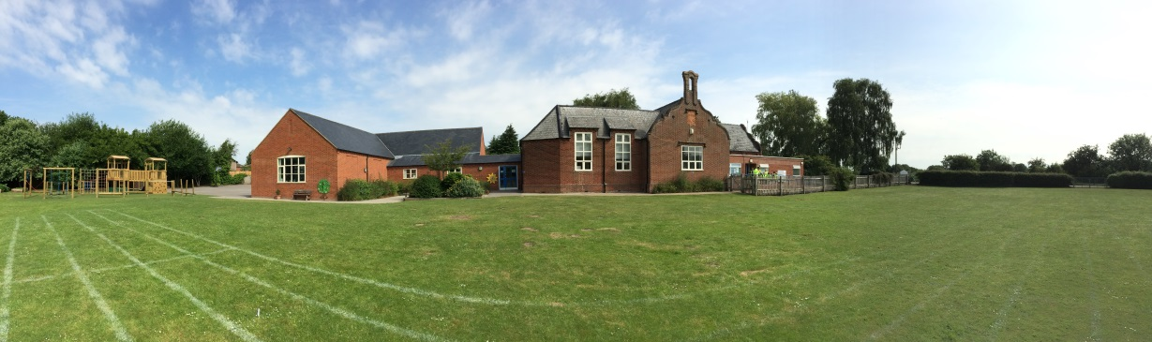
Equipment

The school provides all the necessary equipment for learning. e.g. pencils, pens, rulers, paper, calculators and books so there is no need for your child to bring any stationery from home.

There may be occasions when they will be encouraged to bring items e.g. photographs, toys or other objects to support topic work. You will be informed of these via the newsletter or in separate correspondence.

Charging Policy
From time to time, parents may be asked to make a voluntary contribution towards the cost of additional enrichment activities to cover the costs of craft materials or educational visits or visitors. These additional activities make a valuable contribution to the education of the children at St Faiths’, but no additional funds have been made available to schools to pay for them.

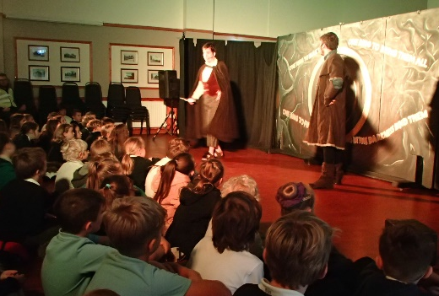 | 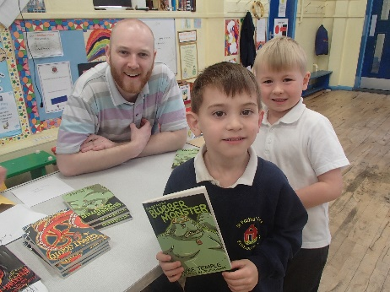
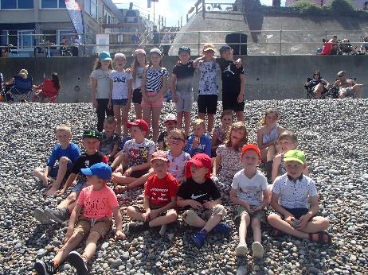 | 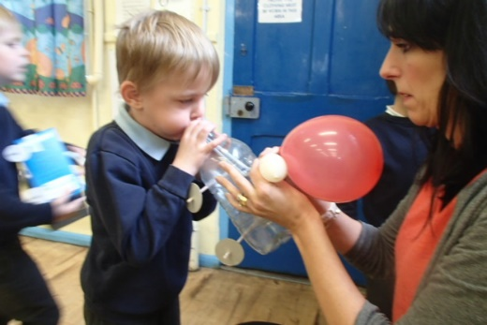

All letters sent to parents giving details of any proposed educational visits give details of costings including any subsidies and invite parents to make a voluntary contribution where appropriate. We believe these activities are incredibly valuable and thank the parents and carers for their support to allow these enhancements to continue.
Behaviour

Every day we recognise and celebrate positive behaviour at St Faiths’. This is achieved through our Merit System. There are different levels of success, outlined below:

Personal Recognition
Children earn merits for positive behaviours seen immediately such as:
- Good manners
- Walking sensibly around school
- Being a good role model
- Eating sensibly at lunch
- Being helpful
- Holding doors for others
- Full marks in spelling tests
- Good pieces of work

These merits accumulate on merit cards and the children receive rewards for complete cards.

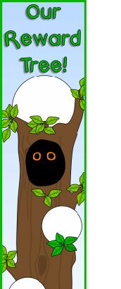 | Class Recognition  Each class has a visual display to act as a class reward system. The class decides what possible rewards they would like each year and these can be achieved using the class ‘tree’. Each class uses their class bird to move up the tree. This has 30 stages and once complete, the class is rewarded with an afternoon activity, selected at random from the ideas decided at the start of the year.  Some ways to earn a mark on the tree:  - Best attendance each week  - Lining up quietly  - Coming in first to assembly  - Leaving assembly quietly  - Working hard and staying on task

Whole-School Recognition
As part of our Merit System, all children are allocated a house team. We have 4 house teams, named after coastal Norfolk towns:
- Cromer (Blue)
- Sheringham (Yellow)
- Waxham (Green)
- Wells (Red)

For every complete merit card, the children receive a ‘house point’ for their team. These are added to a running display in the school hall during our Celebration Assemblies. House Points are counted twice during the year:
- At the end of the Autumn Term, the house team with the most house points will participate in a Christmas activity
- The main collective goal is a summer picnic at the winning team’s beach in the summer term.

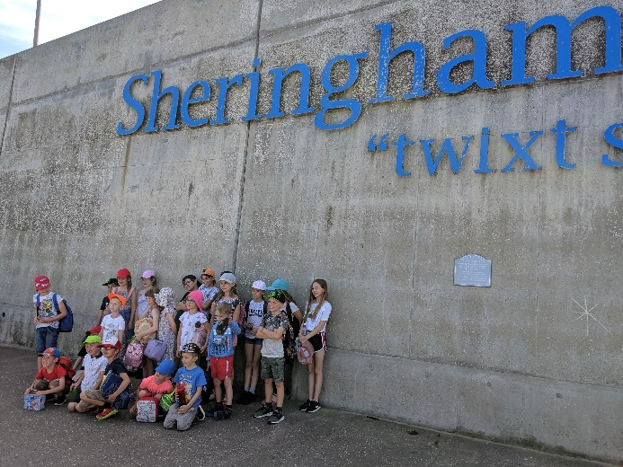  Here are our previous House Team winners – Sheringham! | 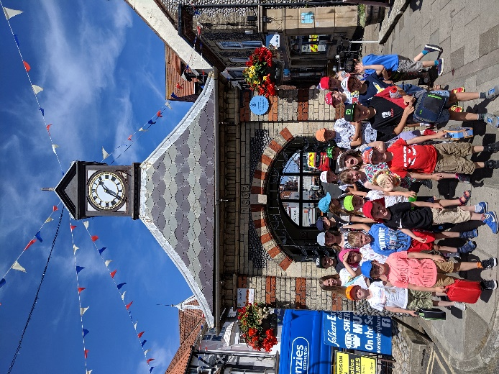

Unacceptable Behaviour
At times when children’s behaviour isn’t as we expect in school, we have a rigorous policy in place to ensure these behaviours are dealt with quickly and efficiently. Any incidences of repeated or heightened negative behaviour will be shared with parents and carers at the end of the school day via a ‘behaviour card’. Clear consequences are also adhered to in line with our Behaviour Policy.
Attendance

Regular attendance at school is a major contributing factor in a child’s progress and success. We ask that you work with your child to ensure they are in school on time each day. We ask that children are only kept off school during term-time if they are unwell.

Please note – there is no entitlement to any leave of absence for holidays during term time. More information about this is provided at the start of each school year but should you have any queries, please contact the school office.

We aim for 97% attendance or better. Patterns of absence will be discussed with the Norfolk Pupil Attendance Officer and will be monitored.

We publish our half-termly attendance every fortnight in our newsletter and the children’s attendance is celebrated every Friday in our Celebration Assembly.

Sickness
Please telephone or email before 8:30am to let us know if your child is absent due to illness. This enables us to ensure that each child is safe and that both parent and school know of their whereabouts. Upon return, an absence note is required, as this is filed in your child’s records.

Should your child be taken ill at school, our staff will contact you to arrange collection for your child to care for or treat at home. In the case of stomach bugs, we request that your child is kept at home for 48 hours after the last bout of illness.

Medicines
Children that require inhalers in school will have an allocated place in each class to store these. They must ask a member of staff before administering their inhaler independently. A record of this is then kept in school. Unfortunately, we are unable to administer prescribed medication to children as we have nowhere to safely store these medicines. Please contact the school office to make necessary arrangements for prescribed medication.

Safeguarding

We are committed to safeguarding the welfare of children at our school. The safety and security of pupils, staff and visitors is taken very seriously by the Head of School and Governing Body and this aspect of our work is subject to regular review.

All staff recruited to the school are subject to an enhanced DBS check as are our regular volunteers. Supply teachers and external staff used to deliver our extra-curricular activities programme have DBS clearances checked before commencing work. All other visitors to school are overseen by staff and are not allowed unsupervised access to the children.

Staff have a legal duty to follow procedures laid down by the Norfolk Area Child Protection Committee if they see signs which suggest that a child has been a victim of abuse. The use of these procedures is a legal obligation placed upon the school and the use of them in no way infers that a parent/carer is being accused of wrongdoing.

There are occasions when children are photographed or filmed as part of school activities. Consent forms for this are included in the admissions pack for all pupils new to the school.

Pupils are required to access the internet to support aspects of their learning. All computers have a high level of filtering provided through the Norfolk Local Authority to minimise the likelihood of pupils encountering undesirable web content. The school has an ICT and e-Safety policy available to view. Children are taught about the safe use of the internet in lessons and have access with adult supervision. We annually participate in ‘Safer Internet Day’ to ensure the e-Safety message is reinforced.

Designated Safeguarding Professionals
As part of our commitment to safeguarding our pupils, we have Designated Safeguarding Leads (DSLs) in school. They are:

Executive Headteacher
Mrs A Best-White
Senior DSL  Mrs J Porter | Deputy DSL  Miss K Wilson
Safeguarding Governor
Mrs J Stocking

Health and Safety

We have a Health and Safety policy in place to provide a safe and secure environment at St Faiths’ Primary School. We work in accordance with the Norfolk County Council and carry out regular Health and Safety inspections and fire drills.

At all times, we ensure that appropriate adult:pupil ratios are maintained and risk-assessments are carried out for all activities and school trips.

Please note:
Smoking or vaping is not permitted anywhere on the school site.

We also ask that parents who wish to collect their children with their pets wait on the path a little way from the gate so others can leave confidently at the end of the day. Dogs are not permitted on the school site.

Severe Weather
If the school has to close due to extreme weather conditions, parents and carers are advised to listen to BBC Radio Norfolk or Heart FM which gives local school closures at regular intervals.

We will, of course, endeavour to keep you up to date using our in-school communication services. However, it is also possible to find the necessary information on the Norfolk County Council website using the following address:

www.schoolclosures.norfolk.gov.uk

Photo Credit: Alistair Malcolm

Admissions

The Application Process
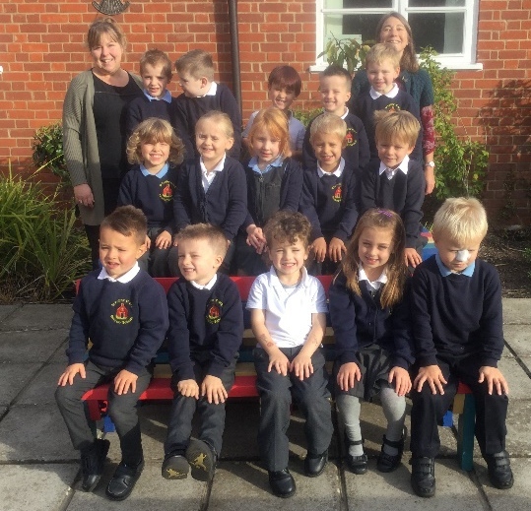
Parents who wish to apply for a place for their child are encouraged to make a visit. The Head of School or House Captains shows prospective pupils around the school and the office will provide parents/carers with an admissions pack containing a copy of the School Prospectus and an admission form.

All admissions to school are dealt with centrally by Norfolk County Council through a common application form that should be returned directly to them. The council will notify parents in writing about whether their child has a place at our school.

Children who reach the age of five between September 2020 and August 2021 will be admitted full-time from the Autumn Term 2020.

Induction Arrangements for First Admissions
When parents have been notified by Norfolk County Council of their child’s place at the school, a letter is sent early in May detailing the school’s arrangements for induction and admission.

To assist the transition into school, pupils are invited to attend morning and afternoon sessions. During the second session, children are given the opportunity to stay for lunch and play with other pupils in the school. We also arrange for parents/carers to attend a short meeting with staff to find out more about the school and ask any questions they may have.

In addition to these induction sessions, the class teacher and teaching assistant arrange to make home visits and local pre-school visits to help forge good relationships and learn more about each child before they start school.

Local Authority Contact Information
Children’s Services Department
County Hall
Martineau Lane
Norwich
Norfolk
NR1 2DL
Tel: 01603 222601
Children’s Services - Schools Information Tel: 0344 800 8001
School Transport Tel: 0344 800 8020
Complaints Procedure

We hope that you will be happy with the education and opportunities which we provide for your child. We aim to ensure that all our pupils are healthy, safe and happy. However, if you have a complaint about the school, please feel free to come and discuss this with us.

We ask that classroom issues are discussed with the class teacher in the first instance. If, after this meeting, the issue has not been resolved then a meeting with the Head of School should be arranged. In the unlikely event of that no resolution to the issue has been made then a formal complaint should be made and the appropriate guidance followed. We strive to ensure that all matters are dealt with quickly, effectively and to everyone’s satisfaction with the child being the central concern.

A copy of the School Complaints policy can be found online at:
www.harnserfed.co.uk

You can also access advice from the Norfolk County Council website.

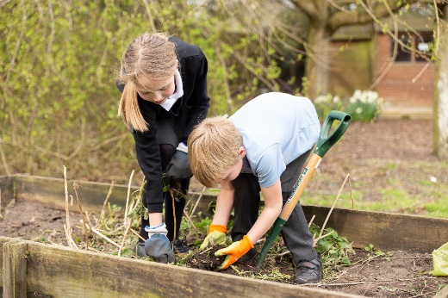 | 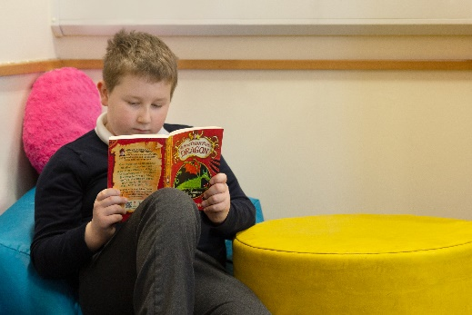
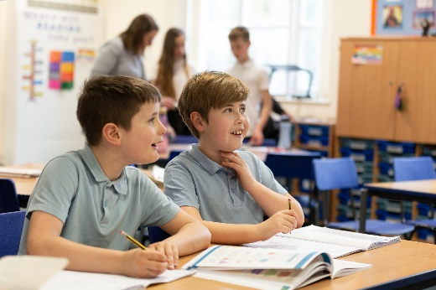 | 