Food for Mood: HYDRATION
Family orientated tips for Children’s Mental Health Week
Looking after our mental health and well-being isn’t always easy. And it is especially hard during a pandemic and lockdown! But we need to pay as much attention to our mental health as we do our physical well-being. As part of Children’s Mental Health Week I am producing a series of handouts to provide simple family-orientated tips to support and encourage better mental health. This one focusses on the importance of making sure you are well hydrated.
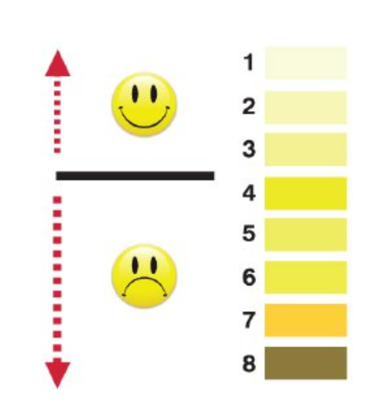
Feeling tired and low in energy can be a sign that you are not drinking enough water. The colour of urine varies from person to person by can be an indication of how hydrated you are. If it is very dark, you may need to drink more.

You should be aiming to drink around 6-8 glasses or 1.2 litres of water per day. However, not everyone likes drinking plain water. If this sounds like you, try adding a slice of fruit (orange, apple, lemon) to your glass to add a little flavour and colour. Fill your water bottle each morning and sip it throughout the day.
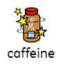
Try to limit the amount of tea, coffee, cola and energy drinks you drink as these contain caffeine which may interfere with blood sugar levels, energy and sleep.
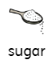
Drinks such as soda, pop, cola, lemonade and even pure fruit juice contain a lot of hidden sugar, which just like sugar found in sweets and refined carbohydrate, can cause your blood sugar levels to go up and down which can affect your energy and mood.

Just one 330ml can of Coke contains 35g or 9 teaspoons/cubes of sugar, so this would be more than your whole day’s recommended intake in just one drink!

