Class 2 Home Learning
w/c Monday 1st June 2020
Daily Activities
15 mins  Times Tables Rockstars/  Hit the Button |  | 15 mins  Spellings:  Vowel phonemes: ure and ire |  | 10 mins  Reading
Weekly Activities
(all to be completed across the week and evidenced on Seesaw using your Home-Learning code)
Maths
1  MyMaths:  ‘Commutativity: multiplication’ and ‘Mixed tables: 2, 5, 10’ |  | 2  ‘Multiplication/division relationships’  and ‘12’ |  | 3  Make arrays with items from around your house. Write the multiplication and division calculations to go with.
Comprehension
The Enormous Turnip
(Choose 1, 2 or 3 stars)
Science
Make your own ice cream
(instructions on Seesaw)
Writing
1  Write an acrostic poem for a particular food. |  | 2  Write a recipe. How to make…  Include a list of ingredients and use clear steps. |  | 3  Write a review of a meal you have eaten. Make it really descriptive.
Enrichment
Create a shopping list. Make sure your items ensure your family has a balanced diet. |  | Design a milkshake. |  | Create and have a picnic together.
Learning Project – Food

The project this week aims to provide opportunities for your child to learn more about food. Learning may focus on where different foods come from, what makes a healthy meal, opportunities to cook etc.

A balanced diet:  What makes a balanced diet?  What can you remember about the 5 food groups (carbohydrates, proteins, dairy, fats, fruits and vegetables)?  Can you create a school menu using what you know?  Other things to think about:  Where does your food come from? Which food comes from the UK? What is Fairtrade? |  | Food art:  Have a go at sketching some fruit and vegetables in your home.  Find out about the work of Lynne Flavell (link on Seesaw). Can you create some art like hers?  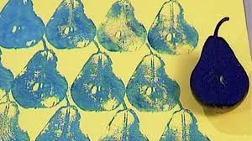  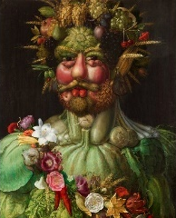  Take a look at the art  of Giuseppe  Arcimboldo. Can you  create a face using  fruit and vegetables like him? |  | Understanding others:  Can you find out about different foods from around the world? What are some traditional foods eaten in other countries?  Have a look at the short video about different lunches around the world (link on Seesaw).  Can you find out what a vegetarian is? Vegan? Kosher food? Halal food?
Keeping Active
(Try at least two of the following this week. Get your family involved too!)
 | Joe Wicks  Daily workouts on Youtube |  | BBC Supermovers  Choose 2-3 different videos |  | Cosmic Kids  Available on utube
 | real PE  (password emailed to parents) |  | Active Norfolk  https://www.activenorfolk.org/active-at-home |  | Get Outside  Go for a walk/cycle around your local area

