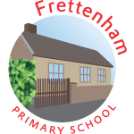
Welcome to
Class 1

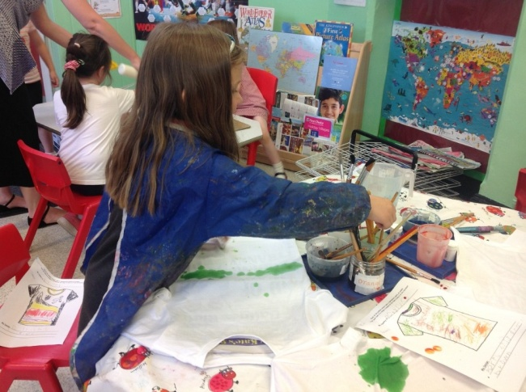

Information for Parents

Welcome
Welcome to Frettenham Primary School and to Class 1.

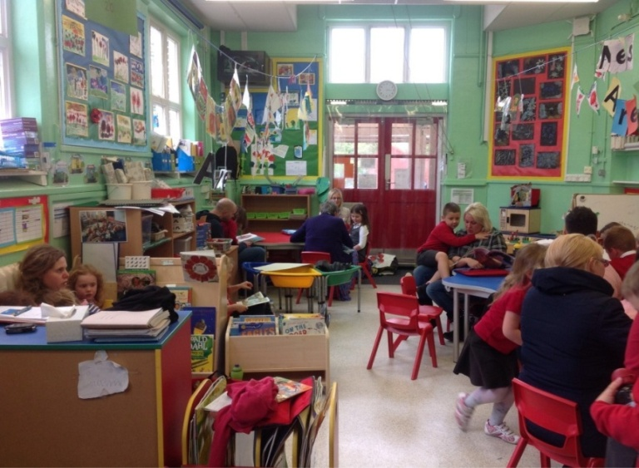
From the very start of their school life, children at our school are encouraged to be independent. The classroom allows children opportunities to make choices and decisions in a safe environment with adult support and encouragement. Children line up on the playground and are greeted by their teacher at 8:45am.They are brought into the classroom through the red double doors under the canopy. At this time, parents are encouraged to say goodbye and children come into the classroom to put away their coats and book bags independently.

Throughout the day, the children access all the areas of the curriculum through both adult directed and independent activities. The school day begins with a whole-class registration and introduction to the day’s activities. The rest of the day consists of a mixture of time for the children to develop their learning, either individually, within a small group, with a teacher or as a whole class. The children are encouraged to develop their learning independently through play, both indoors and outdoors.

Each day, the children will take part in short carpet sessions focussing on the maths topic of the week, phonics skills for reading and writing and a learning review to provide the children with the opportunity to reflect on the skills they have been developing through their play. At the end of the day, the children are brought together for a short circle time and a story before they go home.

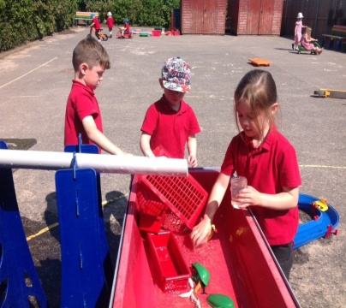
At lunch time, the children can choose between having a hot dinner or a packed lunch brought from home. When the children have finished their lunch, they will join the rest of the school on the field or playground. This gives them the opportunity to mix with other children and experience a range of play equipment and games.

At home time, parents wait on the playground outside Class 1 and children will be dismissed at 3:00pm when the teacher can see the parent (or collecting adult) has arrived.

Home Visits
Every child is offered the chance to have a home visit. We feel it is important to talk to and interact with children, parents and carers in an environment where the child will feel comfortable and relaxed. Please note that the home visit is optional. Class 1 staff will visit your home and give you all the information you require before your child begins school. This will be an opportunity for us to find out more about your child and for you to make us aware of any issues regarding your child’s progress or needs.

Each visit lasts around fifteen minutes and you will be given time to talk to the teacher and ask any questions you may have about your child starting school. We want to ensure that you and your child have plenty of time to talk and become familiar with us before school begins. We want your child’s start at school to be as smooth as possible. We recognise that, as parents, you know your child best and any information we can gain from you to help us to settle them will benefit everyone involved.

What should you expect in your child’s first week at school?
The most important thing you must remember during your child’s first week at school is that there are other children and their parents going through the same experience. This is a big step in your child’s development and a significant shift in their routine. We understand that every parent worries about their child’s first week at school. It is our aim to support you and your child as much as we possibly can during this time and in the future.

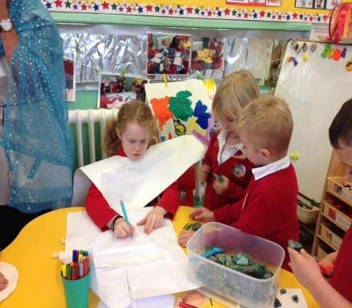
Below are some tips that will help you to support your child during their first week at school:
Have a morning routine at home.
Speak confidently and positively about school.
Get to school promptly.
Reassure them that they will have lots of fun!
Tell them that all the parents/ carers have to go
home.
Say goodbye quickly and reassure them that they will
have a good day.
If your child holds on to you, allow their teacher or teaching assistant to take them from you.

What will your child need to bring to school?

We take pride in our uniform. All items can be purchased from Tesco (see Prospectus and leaflet in Welcome Pack)
Please ensure ALL items of clothing are named, even coats and shoes!

Waterproofs and Wellies We encourage the children to take their learning outside and we like to get out there in all weathers. If your child has waterproof clothing and wellies in school, it will enable them to make the most of these opportunities.

Weather-appropriate clothing Children love to play outside whatever the weather, so it is advisable to ensure that children always have a light waterproof coat and a sun hat in school to ensure that they are always prepared, along with a change of clothes for emergencies.

P.E. Kit P.E. bag, containing shorts, a t-shirt and trainers/ outdoor shoes. A jumper and jogging bottoms can also be provided in the Winter months. Spare clothes (socks, pants, trouser/ skirt, t-shirt) can also be placed in this bag, within a plastic bag

Book bag Book bags can be purchased from Tesco (see leaflet in Welcome Pack) and should be brought to school every day. Your child will be given the opportunity to choose a book to share with you at home. Keep this and any other school books in this bag for easy access when they are needed in school. Any letters from school will also be placed in here.

Hot Dinners/ Packed Lunch School meals are available for free every day. A menu for the term is provided in the Welcome Pack and is available online. Your child may have a school dinner every day or may choose to eat when their favourite food features on the menu.
Some children choose to have a packed lunch- parents sometimes find this an easier way to monitor how much their child is eating and know they can provide some of their child’s favourite foods. Please ensure that lunchboxes are named!

Water Bottle Fruit snacks and water are available at break time, but we do advise that children bring their own named water bottle that they can access at any time. This should contain only water if it is to be drunk in the classroom.

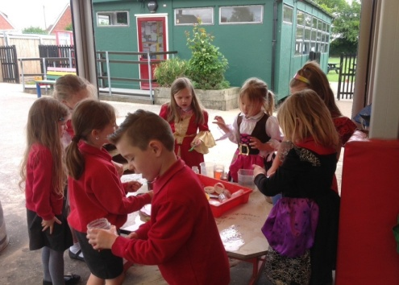

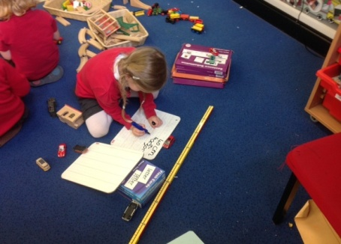
The Curriculum
Throughout their time in school, the children learn a wide
range of skills. Activities are planned in line with the
Early Years Foundation Stage curriculum.

The curriculum is split into seven main areas of learning. These are:
Personal, Social and Emotional Development
Talking about personal experiences, getting to know ourselves and the people around us. An introduction to Religion and Religious festivals.

Communication and Language
Speaking and listening skills, understanding of language.

Literacy
Letter recognition, reading, writing, letter formation, pencil control, knowledge of books.

Mathematics
Number, counting, shape, pattern, money, measure and estimation.

Understanding the World
Life processes, understanding of living things and how to care for them, our environment, life in the past, designing and constructing and using ICT in everyday life.

Physical Development
Understanding how the body develops and changes, ball skills, balancing, following instructions, sequencing activities and controlling movements.

Expressive Arts and Design
Pencil control, drawing, pattern, colour, paint, colour mixing, using powder paints, texture, collage, 3D construction and modelling, music and role-play.

The Foundation Stage Profile

The Foundation Stage Profile focuses on your child’s achievements in the seven areas of learning. In order to keep track of what your child has achieved during the year, we will make observations, take photos and keep notes on what they are doing. When your child has achieved something in one of the seven areas of learning, we will record their achievement on their Foundation Stage Profile via ‘Tapestry’- an online learning journal. Each child is taught according to their own learning style and needs. All children are individual and we recognise that they each have their own strengths and areas for development. By keeping a record of what your child is achieving, we are able to focus our teaching to your child’s individual next steps. It is our aim to ensure that they get exactly what they need to enthuse, encourage and move them on.

Whole School Routines

Celebration Assemblies
The Reception children will attend assembly in the Log Cabin on a Friday afternoon. The children will be a part of the school’s Celebration Assembly, during which the whole school come together to celebrate the achievements of the children, both inside and outside of school; to find out which class has had the highest attendance and to see which group are in the lead for the House Point trophy.

Assertive Mentoring
Teachers are available and happy to speak with parents after school most days. If you have something that you would like to discuss with them, please make an informal appointment. During the year, there are three formal occasions where you can meet with your child’s teacher to find out how your child is progressing and how you can support them at home. Towards the end of the Summer term, teachers and parents will meet to discuss your child’s end of year report which records their progress and achievements for the year.

Class Routines

P.E.
Your child will take part in regular P.E. sessions. Please ensure that your child’s P.E. kit is in school every day. These sessions will take place at least once per week and the day and time may change dependent on the activity and who is teaching the sessions. Throughout the year, your child will have opportunities to develop their skills in listening and team games, throwing and catching, gymnastics and dance.

Playtimes
Playtime each morning is at 10:45am to 11:00am.
This is a time for the children to socialise with their classmates and the children across the rest of the school, eat a healthy snack and take in some fresh air.
Playtimes are also an opportunity for children to go to the toilet. These facilities are available throughout the day and children are encouraged to go as and when they need to.

Family Reading
Class 1 invite family members in to the classroom or the school library to share a book with their child. This is also a time when Class 1 children can choose a library book to take home for the week.
This will take place throughout the Autumn and Spring terms, day and time to be confirmed.

Reading Books
Children must bring their reading book to school every day. Staff will aim to change reading books once a week. Parents are welcome to come into school to change their child’s reading book as often as they like in-between these days.

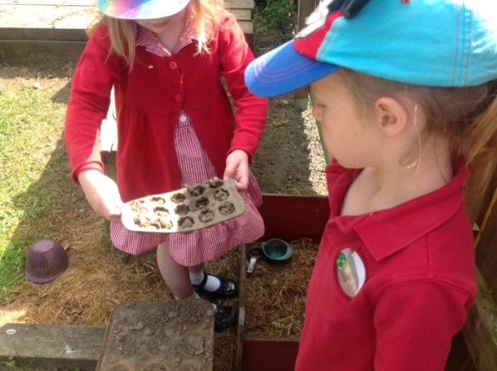
Supporting Your Child

Throughout your child’s times at school, the teachers will work hard to ensure that they make the most of every opportunity they are given to make progress. It is important that this is reflected at home through the valuable support parents and carers provide.
We aim to provide many opportunities for parents to come into school to find out what the children are doing. Each week, we send home information about our topic with ideas for parents to help support their child’s learning at home.

Reading and Key Words
Each child is given a reading diary to keep in their book bag. Parents are encouraged to write positive comments in this book when they listen to their child read. Teachers and Teaching Assistants will also do this when they hear your child read.
Throughout the year, your child will bring home a bag of word cards. These words will be added to as the children encounter more words in their phonics learning.

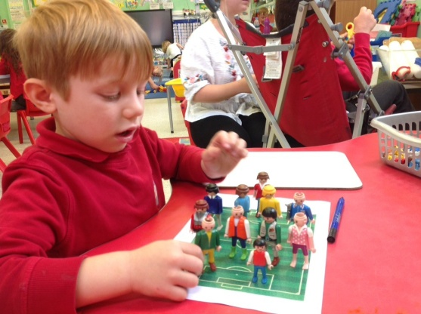

Stay and Play
During the first term of school, you will be invited into Class 1 to join the children for a few afternoon sessions. During these sessions, you will be given the opportunity to see how the children are taught and how each area of the curriculum is met through carefully planned play activities whilst exploring with your child.

