

**\*History: Timeline:** **What celebrations have you joined in with in your lifetime so far? Can you place them in order on a timeline?**

**\*Art/ DT:** Make decorations for a celebration. **What materials will you use?**

\***Art: Firework Art:** Create some firework artwork**.** There are lots of examples online!

\***Geography/ R.E.: Festivals:** Make a list of festivals and celebrations. Mark on a map where each one takes place. **How are they similar and different?**

**Maths-** Time- Seasons and Months

*Sing the ‘Months of the Year’ song: <https://www.youtube.com/watch?v=5enDRrWyXaw&safe=active>

*Can you write the months of the year in sequence?

*Celebration Book: Create a celebration book. **Which celebrations take place in each month?**

*Seasons Calendar: Draw a picture to represent each season. **Which months go in each season?**

**Celebrations**

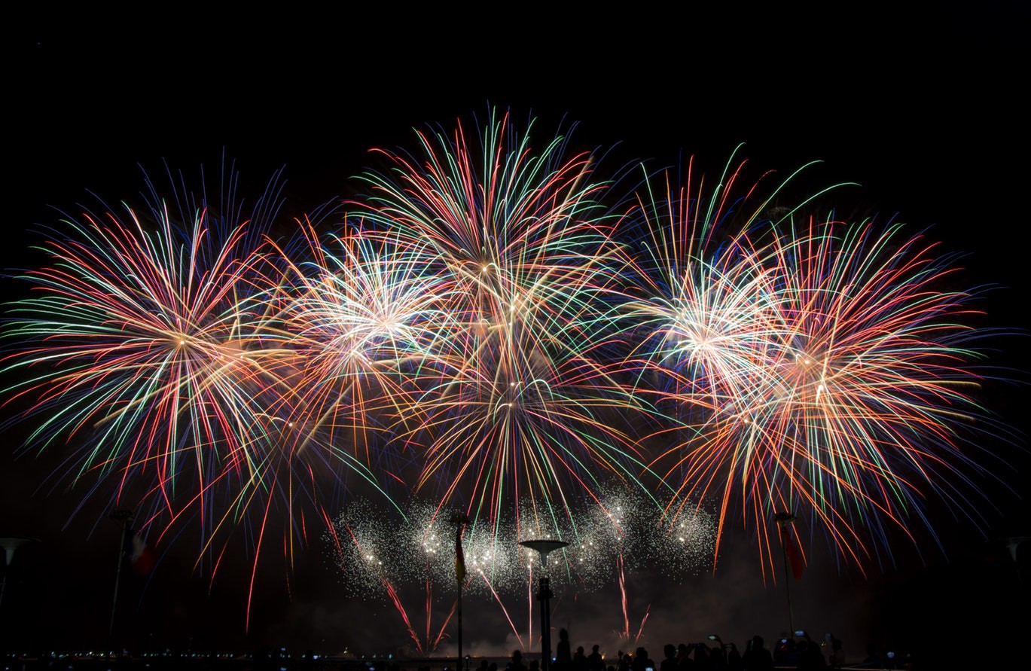

Project borrowed from Robin Hood MAT

**Enrichment Activities**

 Plan a Party!: **What will you celebrate? Where will it be? Who will you invite? What will you do?**

Bake a Cake!: Bake a cake for a celebration. **What ingredients will you use? Can you write the recipe? How will you decorate it?**

 Yoga Disco: Go to the ‘Cosmic Kids Yoga Disco!’: <https://www.youtube.com/watch?v=dw-0bmtDPnk&safe=active>

**Writing**

*Make a Card: Design a card for a celebration of your choice. **Who will you write it to? What will you write inside?**

*Invitation: Write an invitation to a party. **What information should you include?**

*Menu: Write a menu for a celebration dinner.

**\***My Own Experiences: Draw and write about a celebration you have enjoyed. **What and how did you celebrate?**

**Reading**

*Read a book aloud to someone at home

*Read a non-fiction book about a celebration

**\***Play some phonics games on:

[www.phonicsplay.co.uk](http://www.phonicsplay.co.uk) or [www.phonicsbloom.com](http://www.phonicsbloom.com)

**\***Read the story ‘Kipper’s Birthday’ by Mick Inkpen (see Powerpoint)

Make a list of all the time words you can find

*Reading comprehension (See resources)

**Daily Expectations**

• Spend 15 minutes reading- books, comics, magazines- any reading is great!

• Spend 15 minutes doing some maths on **Numbots**, **Sumdog** **or** **My Maths**

• Practise reading and writing these words:

* **put**
* **push**
* **pull**
* **full**
* **today**

Write each one in a sentence. Can you use more than one?