Welcome to Hainford VC Primary School

A warm welcome to Hainford VC Primary School, we thank you for taking an interest in our school.

We are a small rural school which has a wonderful family atmosphere because the staff know the children well and children of all ages learn and play together. We provide a lively and creative curriculum where individual children’s needs are met.

This prospectus will give you an idea of school life at Hainford Primary School where we like to work in partnership with parents and carers to provide a happy and safe learning environment for you and your child. For more detailed information please visit our website at: www.harnserfed.co.uk

Our school works as part of the Nebula Partnership. The Head of School is responsible for the day-to-day management of the school. The role of the Governing Body is to provide strategic management to act as a “critical friend”, supporting the work of the Executive Head and staff.

Hainford V.C. Primary School: School Site

Hainford Primary School is a small village school situated in the centre of the village which is north of Norwich. The school currently caters for pupils aged 4-11 and has existed since the 1870’s. The school serves the villages of Hainford and Stratton Strawless. Many educational and social changes have taken place in this time and Hainford Primary School has always responded to the challenges of meeting children's educational needs in a positive and constructive way. The school is a Church of England Voluntary Controlled school with close links to the Church and a strong Christian ethos.

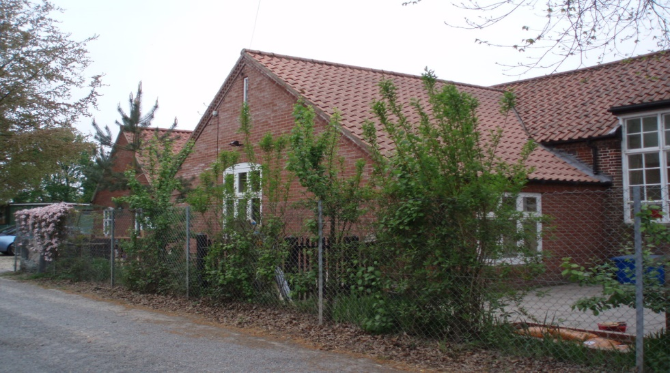
Dropping off and collecting children

The school gate (nearest to the adventure playground) is opened from 8:30 to allow children and their parents / carers onto the school premises at the start of the day. It is locked promptly at 8:50am once parents have completed drop-off.
The gate is then reopened at 2:55pm ahead of the end of day at 3pm.

Reception:
Our reception is located down the track directly opposite Dumbs lane and off Newton Road. The office is staffed between 8:30 – 3:15. If you need to speak to a member of staff or need access to the school premises then please head towards reception.

