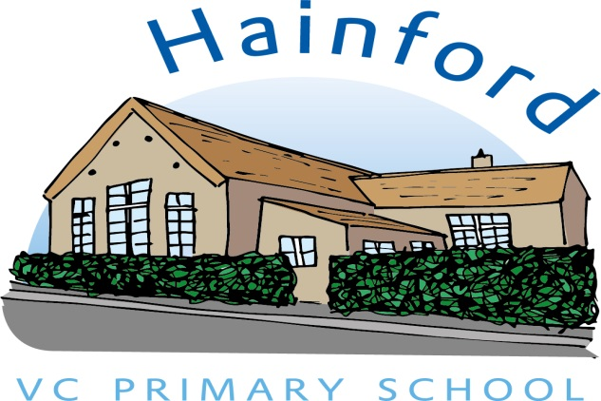

**Hainford V.C. Primary School**

**Part of the Harnser Federation and Nebula Federation**

***Prospectus***

**Executive Head: Mrs Ashley Best-White**

**Head of School: Mr P Cross**

**Chair of Governors: Judy Leggett**

Hainford V.C Primary School

Newton Road

Hainford

NORWICH

NR10 3BQ

Telephone: 01603 898359

Email: office@hainford.norfolk.sch.uk

**This prospectus provides you with only some of what school-life is like at Hainford. For more detailed information including policies, key information and dates please visit the school’s website at:**

**Website: http:** [**www.harnserfed.co.uk**](http://www.harnserfed.co.uk)

Prospectus Contents

|  |  |
| --- | --- |
| **Contents** | **Page Number** |
| Welcome | **1** |
| Our Site | **2** |
| Our Staff | **3** |
| Our School & Federation Values and Aims | **4-5** |
|  |  |
| **Essential Information:** |  |
| Safeguarding | **6** |
| Meeting Individual Needs | **6** |
| Equal Opportunities / Admissions | **7** |
| The School Day (Times) | **7** |
| Before School  Time Keeping and Attendance  Collecting Children | **7**  **7-8**  **8** |
| Assessment and Reports  School Organisation & Assertive Mentoring | **8**  **9** |
| Encouraging Good Behaviour | **9** |
| Information required by the school | **10** |
| School Dress including P.E. kit | **10-11** |
| Volunteers in School | **11-12** |
| School Meals | **12** |
| Medication | **12** |
| Health and Safety (Adverse Weather) | **13** |
| Special Needs | **13** |
| Educational Visits | **14** |
| Charging for Educational Activities | **14** |
| Concerns | **14** |
| Transition | **14-15** |
| Friends of Hainford | **15** |
| Our School Curriculum  Admissions Process | **15**  **16** |
|  |  |

**Welcome to Hainford VC Primary School**

A warm welcome to Hainford VC Primary School, we thank you for taking an interest in our school.

We are a small rural school which has a wonderful family atmosphere because the staff know the children well and children of all ages learn and play together. We provide a lively and creative curriculum where individual children’s needs are met.

This prospectus will give you an idea of school life at Hainford Primary School where we like to work in partnership with parents and carers to provide a happy and safe learning environment for you and your child. For more detailed information please visit our website at: [**www.harnserfed.co.uk**](http://www.harnserfed.co.uk)

Our school works as part of the Nebula Partnership. The Head of School is responsible for the day-to-day management of the school. The role of the Governing Body is to provide strategic management to act as a “critical friend”, supporting the work of the Executive Head and staff.

**Hainford V.C. Primary School: School Site**

Hainford Primary School is a small village school situated in the centre of the village which is north of Norwich. The school currently caters for pupils aged 4-11 and has existed since the 1870’s. The school serves the villages of Hainford and Stratton Strawless. Many educational and social changes have taken place in this time and Hainford Primary School has always responded to the challenges of meeting children's educational needs in a positive and constructive way. The school is a Church of England Voluntary Controlled school with close links to the Church and a strong Christian ethos.

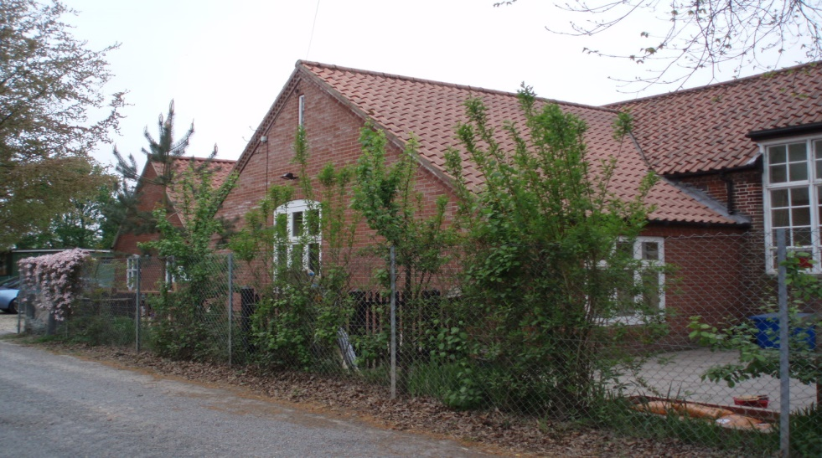

**Dropping off and collecting children**

The school gate (nearest to the adventure playground) is opened from 8:30 to allow children and their parents / carers onto the school premises at the start of the day. It is locked promptly at 8:50am once parents have completed drop-off.

The gate is then reopened at 2:55pm ahead of the end of day at 3pm.

**Reception:**

Our reception is located down the track directly opposite Dumbs lane and off Newton Road. The office is staffed between 8:30 – 3:15. If you need to speak to a member of staff or need access to the school premises then please head towards reception.

Our Staff

**Executive Headteacher** Mrs Ashley Best-White

**Executive Deputy-** Mrs Jenni Porter

**Headteacher**

**Head of School** Mr P Cross

**Class Teachers**

*Miss J Harris: Class 1 (Reception & Year 1)*

*Mrs J Mellows: Class 2 (Year 2 & 3)*

*Miss A Williams: Class 3 (Year 4, 5 and 6)*

**Teaching Assistants** Mrs S Cooper

Mrs S Allison

Mrs P Spall-Hanson

Mrs L Spencer

Mrs F Pamment

**Secretary** Mrs F Pamment

**Caretaker** Mr G Botwright

**Cook** K Ashby

**Catering Assistants** N Lofty

**Midday Supervisory Assistants**

Mrs T Rudd

Mrs B Beatty

Mrs S Bedder

**Nebula – The Partnership of Six Schools**

The Nebula Federation believes that all schools are more effective when they work in partnership than when they stand alone. We value and embrace each school's uniqueness and the community it serves, whilst seeking to learn from and share with each other so that we spread excellence effectively.

The Nebula Partnership provides a means of bringing schools together, serving a common purpose and providing continuity in learning from Early Years through the Primary age range.

**Vision and Aims**

It is the belief of the governors that Nebula will provide a strong entity through which we are able to create stronger partnerships and collaborate more for the benefit of our children and community.

Governors believe that, in order to meet the needs of our school community, having a shared strategic vision will be a powerful method of ensuring standards continue to be raised, and that the six schools remain effective and viable organisations in a time of financial constraint.

Our partnership aims to not only transform the life chances of every pupil that passes through it but to also have a lasting and positive impact on the wider community as well.

**We will aim to:**

* Put children at the centre of everything we do.
* Take collegiate responsibility for improving the life chances of children within our partnership, raising aspirations and promoting lifelong learning;
* promote excellence and continuity of teaching and learning for all our pupils;
* build a coherent, creative and inspiring learning journey by working together and, with our local pre-school, infant and secondary schools, ensure effective transition to each new stage of learning;
* ensure consistently high expectations of achievement across all of our schools:
* work effectively with parents and carers, professionals and the wider community to promote health and well-being, always seeking to promote the right conditions in which children can thrive;
* share resources and work with external partners to widen the range of opportunities available for our pupils and their families
* develop a highly skilled workforce by providing effective professional development, and sharing expertise.

**Values**

***The overall values of the Partnership are:***

* **Opportunity** - to ensure that all pupils receive an outstanding education in a fully inclusive community
* **Resilience** - to be willing to adapt and change to respond to the needs of the school Community, to be enterprising and have the ability to take managed risks;
* **Excellence** - to critically evaluate leadership and teaching to ensure that the best possible provision can be developed
* **Aspiration** - to ensure that leaders have high aspirations for all pupils in our Partnership schools
* **Inspiration** - to test our educational thinking to understand that there are always routes to improving provision
* **Strong Sense of Self** - to develop confident individuals who learn to recognise and value their own talents and ambitions and to support learners to reach and exceed expected standards of attainment and we will be leaders of educational change in the wider community.

Our Christian Values and Collective Worship

Collective worship provides opportunities to celebrate and reflect together upon the beliefs, values and practices of the school community.

Aims;

* To provide opportunities for pupils to worship God.
* To enable children to consider spiritual and moral issues.
* To enable children to explore their own beliefs.
* To encourage participation and response.
* To develop in children a sense of community spirit.
* To promote a common ethos with shared values and reinforce positive attitudes.

**Useful Information for Hainford V.C. Primary School**

**Safeguarding**

Child protection

The school is committed to ‘Safeguarding’ in all aspects in respect to children and adults in our care. Robust procedures are in place and the Norfolk Children’s Services policy has been adopted by our Governing Body.

All visitors to the school are required to report to the school office first, for security reasons. There are padlocks on the entrance gates to the playground and a security lock at the main entrance to the school. We have a Safeguarding Policy in place that is regularly reviewed. All staff and volunteers are aware of our procedures and have been subject to the necessary vetting security checks.

Our Executive Headteacher, Mrs Best-White, is our designated Safeguarding Person and all staff receive safeguarding training and updates annually. If you have any concerns, please speak with the Head of School. Jenni Porter is the Senior Designated Professional in the Head of School’s absence.

This school is committed to promoting the health and welfare of all pupils. We are required by law to follow procedures laid down by the Norfolk Area Child Protection Committee, if we see signs which suggest that one of our pupils may have been a victim of abuse. Use of the procedures in this way is an obligation placed on the school by legislation and in no way infers that the parent/carer is being accused of any wrongdoing.

Safeguarding and the Curriculum

Areas of the curriculum educate children about safeguarding issues, for example through Personal Social Health Education and topics such as using the internet safely, drugs, sex and relationships. Safety issues and subjects are discussed and safe practises are also taught, for example through the safe use of play and PE equipment.

**Meeting Individual Needs**

We welcome all children and will meet their needs in a caring and positive way. We are an inclusive school where all pupils are valued and we recognise that they all learn in different ways. Some pupils may require additional support and some may benefit from extension activities. Our aim is the inclusion of all children in a broad and balanced curriculum. The appropriate learning needs of all children are met through differentiated work or individual support programs. We have a Single Equality Policy and Accessibility Plan in place which can be viewed upon request. We follow the Code of Practice and guidelines relating to Special Educational Needs. If you have any concerns about your child joining our school, please come and discuss your child’s needs.

**Equal Opportunities Statement**

Hainford Primary School positively encourages equality of opportunity with regard to gender, race, disability and class. It opposes any form of discrimination and encourages all pupils to see themselves and each other as unique and special people. The school's organisation, curriculum, staffing and pastoral/social responsibilities seek to reflect this statement.

**Admissions**

The schools operate the standard Norfolk LEA Admissions Policy. In the summer term each year, there are induction visits for pupils who are to start in the following September, and home visits will be arranged for the children’s class teacher and their teaching assistants. There is also a meeting for the parents of those children. In addition, the Heads of School will be pleased to see any parent regarding admission throughout the year.

**The School Day**

**Session times**

|  |  |
| --- | --- |
| Registration | 8:45am |
| Morning Session 1 | 8:45 to 10.20 |
| Break | 10:45 to 11:00 |
| Morning Session 2 | 10:50 to 12.00 |
| Lunch | 12.00 to 1.00 |
| Assembly / Collective Worship | 1:05 to 1:20 |
| Afternoon Session | 1:20 to 3:00 |
| Home time | 3:00pm |

**Before School**

The school day starts at 8.45 a.m. The children should arrive after 8.30am, as we are unable to supervise children before this time. Children remain the responsibility of their parents until the school gates are opened at 8.30am when a member of staff will be on duty.

**Time-Keeping and Attendance**

The School day begins at 8.45am. The children must be ready to come into school by this time. At Hainford V.C. Primary School we want all children to learn the value of good time-keeping. The children have a full day's activities. If a child is late, he or she will miss part of the curriculum. This time is never made up and persistent lateness will affect your child's progress in school. Parents and carers can help by making sure that their child learns the useful habit of arriving on time. This will help them at school and later on within the world of work.

Parents and carers should ensure that their child comes to school every day. They must tell us when their child is unavoidably absent, either by note or by phone. We also need to know about dental, clinic or hospital appointments.

If your child's absence is not explained by either note or phone, the school has to record it as unauthorised. Therefore, it is very important that children arrive at school and are collected on time, as appropriate for their age. They must come to school every day and a message must be sent if they are ill.

In the interests of safety, please refrain from bringing dogs on to school premises. Please use the access route clearly marked into school.

**Collecting Children**

Parents/carers should collect their child from the playground at the end of each day. Please always contact school if you are unavoidably delayed. We have an answer phone on which you can leave messages. Children who are not collected when they are expecting to be can become frightened and upset. Always make sure the class teacher knows who is collecting your child. Children in Class 3 may return home independently if written permission is given.

**Assessments and Reports**

Pupil progress is continually assessed and careful records are kept by each teacher of pupil achievements and progress. These assessments are used to plan future work and track pupil progress. Pupils are involved in the assessment of their work and are aware of their targets. During Year 2 and Year 6, usually in May, children undertake Standard Assessment Tasks (SATS). The results of these are sent to the DfE and Local Authority, and are reported to parents. Regular parent’s meetings take place throughout the year. Parents also receive a termly summary report, as well as a more detailed report in July. Parents are always welcome to discuss their child at any time. In each subject area there are clear age-related expectations which reflect difference in achievement, depending both on pupils’ abilities and upon which key stage they are working.

In addition, the children take internal assessment tests in mathematics and English at the end of each half-term. At the end of each term, Years 1-6 will sit longer assessments in order to more accurately identify progress.

The assessment arrangements also include continuous assessment by the class teacher.

**Assertive Mentoring**

Parents are invited to Assertive Mentoring meetings four times a year where they can discuss their child's progress with the class teacher. These will take place at: the start of the academic year; around the October half-term; around the February half-term and near the end of the year to discuss each child’s end-of-year reports.

Parents are welcome to make separate appointments if they wish to discuss any aspect of their child's development. Please see the class teacher or school secretary to make an appointment.

**School Organisation**

Children are currently organised between three classes. Usually Reception and Year 1 children work together, as do Year 2 and 3. Years 4, 5 and 6 work together, usually with the Year 6s working for some periods separately in the mornings.

**Encouraging Good Behaviour**

Our aim is to have a quiet, calm, secure atmosphere where your child can get the maximum benefit from his or her time at school.

All of you will expect us to keep discipline in school so that your child has the best chance of making progress. We think it is important to recognise and encourage all children who work and behave well. This helps them become confident about what they are doing in school. We encourage positive attitudes, for example by giving praise and encouragement, by allowing children to choose a reward in the classroom and by providing opportunities to talk about good work or behaviour at our Celebration Assemblies.

Occasionally however children forget what we expect from them. We remind them in a number of ways depending on how serious their misbehaviour is. **Please see the Harnser Behaviour Policy available on our website.**

We work closely with parents and children to try and find solutions to problems and to deal with any underlying issues. We expect all parents/carers to support our rules and co-operate with what we are trying to do in school.

From time to time in any school, things do not happen in the way we plan. If we have any worries about your child in school we will ask you to come in and discuss them. If you have any worries which may affect your child in school it helps a lot if you first come and discuss these with the Head of School. If the Head of School is not immediately available, please see the school secretary for an appointment.

**Information Required by the School**

It is important that we have up to date information about where you can be contacted during the day. Please tell us as soon as you change your address, phone number or place of work so that we can contact you in an emergency. The school secretary can supply you with the necessary forms.

**School Dress including P.E. Kit**

All children are asked to wear school uniform; we believe that it helps develop a sense of belonging for the children, as well as being practical, safe and comfortable for the wide range of activities the children encounter during a typical week at school. The full uniform is:

Blue sweatshirt /jumper/cardigan

White or blue polo shirt

Black/grey trousers/shorts/skirt /pinafore dress/leggings

Black shoes

Blue/white checked/striped summer dress

White, black or grey socks

Sensible shoes for safety and comfort are required – these should be suitable for colder/wetter weather

If you send you child to school with shoes that have laces then they MUST be able to tie them themselves for safety reasons.

**P.E. Kit**

In addition, your child must have a full change of ‘kit’ for P.E, (This includes socks and shoes) ready for each P.E. lesson.

All children require:

* Black / dark grey shorts and/or jogging bottoms for colder weather
* A blue or white T-shirt / polo shirt
* Plimsolls or trainers for reception to Year 3.
* Year 4 upwards: Trainers for PE (These provide the grip, strength and support needed)
* A suitable sports jumper/hoodie/top (blue, grey, black)
* A blue/grey/black track-suit is often best for outdoor games in the winter.
* PE kits should be kept in school during the week as timetables can vary.

**Uniform is available to purchase from Tescos online ordering**

**Accessories / Jewellery**

Your child should not wear make-up, nail varnish or jewellery to school. We do not accept responsibility for lost or damaged jewellery worn in error. Watches and stud earrings are permitted but must be removed or covered for PE. Hats should be provided for your child to wear outside on sunny days.

In the interest of safety and in line with Norfolk County Council policy, we ask pupils not to wear jewellery or shoes with high heels or platforms. Pupils with pierced ears may wear plain studs but they must be able to remove them themselves before PE and swimming.

**Water-Bottles**

If you wish to send your child with a water bottle then it must only contain water. Water infuser bottles are fine for pupils to use as long as only fresh fruit is infused and changed daily. Please encourage your child to drink as much as they can during warmer periods.

**Please mark ALL items of clothing clearly with your child's name.**

**Volunteers in School**

We welcome parents, grandparents and other carers into our school to volunteer a little of their time, to engage with the children. Parents enjoy hearing children read, helping on school trips and helping in the library. Some volunteers have special skills and experiences to share with the children. We appreciate and value the time given by parent volunteers, as it extends and enriches the lives of the children. If you are interested in helping in school please speak to a member of staff.

Depending upon the type and level of volunteering that you can offer you may be required to complete a DBS check. Please contact the school secretary in the school office to arrange a convenient appointment.

**School Meals**

 

Children in Reception, Years 1 and 2 are entitled to receive Universal Free School meals. Children can choose from the hot meal on the menu or a delicious Jacket Potato. For KS2 children, (Years 3 to 6) who are not entitled to Free School Meals, school lunches can be ordered at the start of the day. School Packed lunches are also available.

We are very fortunate to have school meals cooked on the premises, serving a choice of main meal and dessert. It helps us if you can send one amount on Mondays in a named purse or envelope for the days that meals are required. You may pay in advance for several weeks but please remember to leave a note each Monday showing the day’s meals are required. Cheques are accepted and should be made out to **Harnser Federation.** Please see the school secretary if you wish to apply for free school meals, which include hot dinners and packed lunches. If you prefer to provide your own packed lunch, please ensure the meal does not include fizzy drinks, chocolate bars or sweets of any kind. We are not able to give credit for school meals.

Please let us know if your child cannot eat certain foods for any reason. Special diets can be catered for, including those with a vegetarian diet. The school meals cater for a range of tastes and there is an emphasis on fresh and healthy food. A copy of the menu is sent home each term.



**Medication**

If your child is taking a prescribed course of medicine and it is essential that a dose is required during the school day, we are able, in most circumstances, to arrange for its administration. Medicines can only be given in school in conjunction with the school’s Administration of Medicines Policy (**please see our website**) All medicine must be prescribed by a doctor, clearly labelled with the child’s name, the dosage and with suitable equipment for administration. We have no refrigeration facilities for medicines in school. All medicines must be brought to and collected from the school office by an adult and a permission form must be signed at the beginning of a course of medication.

**Health and Safety**

We have a Health and Safety Policy and provide a safe secure environment. We work in accordance with Norfolk County Council and carry out regular Health and Safety inspections and fire drills. At all times, we ensure that appropriate pupil/adult ratios are maintained and risk assessments are carried out for all activities and school trips.

Adverse Weather

If the school has to close due to extreme weather conditions, parents are advised to listen to BBC Radio Norfolk or Heart FM which gives local school closures at regular intervals or to look on the Norfolk County Council school closures website. Parents also receive text updates.

**Special Needs (SEND)**

Children are all individuals and develop at their own individual pace. Where we feel that a child is not achieving as well as we would expect we would start a process of identifying and addressing his/her special needs. The child’s teacher, the Special Needs coordinator and parents discuss the child’s strengths and weaknesses and suggest appropriate strategies or learning programmes. This may include giving a child extra support on an individual or small group basis. If the child’s progress is still very slow, with the agreement of the parents, we may call upon the advice of another processional such as an advisory teacher, educational psychologist, speech therapist or occupational therapist. Children whose learning is more severely hindered due to visual or hearing impairment, specific learning difficulties (dyslexia), emotional/behavioural difficulties or poor coordination may be recommended for a formal assessment. This will give a clearer picture of the child’s abilities and may result in a statement of the child’s Special Education Needs and extra resources to meet those needs. Parents are always involved in discussions from the beginning and no decisions are made without parental agreement.

Children all have different needs. Some children need more support than others to help them learn in school. Some difficulties are temporary and some may be long term. In either case, the school will want to work closely with parents to help resolve any problems. The school has an excellent record of working closely with parents and outside agencies to ensure high standards of education and care for all pupils. Any child with Special Educational Needs is monitored regularly by the class teacher & SEND Coordinator. Individual Education Plans are developed and discussed with parents. At termly meetings, extended professional advice may be requested from the Special Needs Support Team. More Able pupils may also be seen to have Special Needs and support is offered to help those children extend & develop their learning.

**Educational Visits**

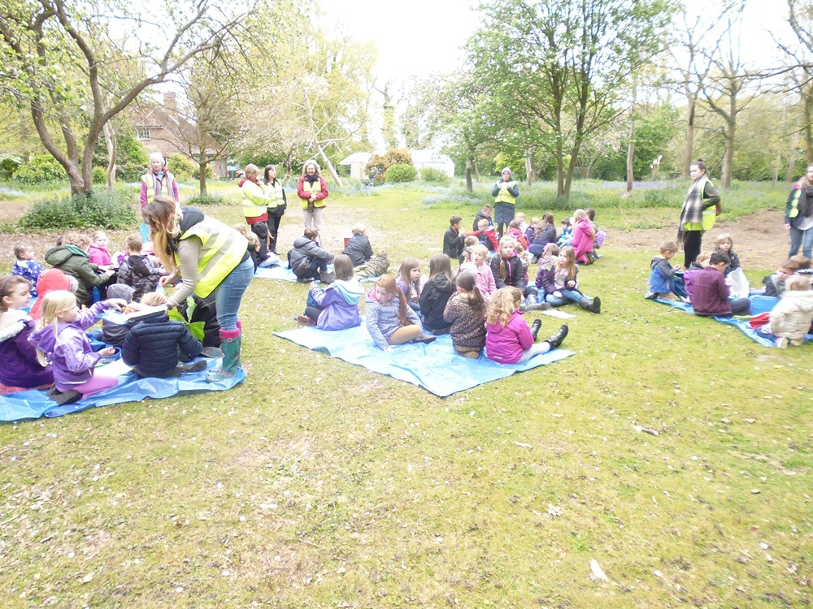

Outings are planned as part of the curriculum. All children will take part unless there are special circumstances. Parents will be given written notice of any trips.

**Charging for school activities**

From time to time, parents are invited to make a voluntary contribution towards the costs of additional ‘enrichment’ activities to cover the costs of craft and cooking materials or educational visits. These additional activities make a valuable contribution to the education of your child but no additional funds have been made available to schools to pay for them.

All letters sent to parents giving details of proposed educational visits etc. gives details of the costs including any subsidies and invite parents to make a voluntary contribution where appropriate. We believe, judging from the supportive response of our parents, that these activities are extremely valuable to the children and that all parents would wish them to continue.

**What to do if you have any concerns**

We recognise that parents, guardians or carers play an important part in keeping our pupils healthy, happy and safe. Co-operation between parents, staff and governors leads to a shared sense of purpose and a good atmosphere in the school. We hope that you will never need to complain, but if you do, the procedures are set out in the Complaints policy available on our website or at the school office. , endorsed by the Governing Body, offers the opportunity for concerns and complaints to be resolved as quickly as possible.

**Transition to Hainford VC Primary School**

There is a close liaison between the school and the Hainford Pre-School Learning Alliance and children are invited to school on a number of occasions in the year before they begin school so that they become familiar with the teachers and the building. Visits are made to playgroup by the Class Teacher and other members of staff and parents are invited to a meeting in the summer term before the children begin school to discuss preparing their child for a happy entry into formal education. All children are invited to an induction period of sessions in school in the summer term. We view education as a partnership between home and school and strive to ensure that all children are educated in a happy, secure environment.

**Hainford Parent Teacher Association**

The recently formed Friends of Hainford contributes greatly to fundraising events in the school.

Throughout the year enjoyable social activities for children and parents are organised by the Group. We want to have everyone's support to make sure the activity is a success and also to give the school an opportunity to create a welcoming school community.

Any money raised on these occasions is used to provide 'extras' for the school in the form of resources and equipment. Fund Raising in the past has helped to provide indoor play equipment, reading books and will be used this year to update our playground markings.

All parents are always welcomed. Meetings are publicised.

**Our school Curriculum**

**The children follow the National Curriculum which comprises:-**

Core subjects              English

                                                Computing

                                                Mathematics

                                                Science

Foundation subjects            Art

                                                Design Technology

                                                Geography

                                                History

                                                Music

                                                Physical Education

                                                PSHE

Languages

In addition to this the school follows the Norfolk Agreed Syllabus for Religious Education. Parents who do not what their child to take part in Religious Education lessons or in collective acts of worship should express their wishes in writing to the Head of School.

Children in Reception follow the Early Years Foundation Stage (EYFS) Curriculum

**The Application Process**

Parents who wish to apply for a place for their child are encouraged to make a visit. A member of staff will show prospective pupils around the school and provide their parents/carers with an admissions pack containing a copy of the School Handbook and an admission form.

All admissions to school are dealt with centrally by the County Council through a common application form that should be returned directly to them. The County Council will notify parents in writing about whether their child has a place at our school.

Children who reach the age of five between September 2017 and August 2018 will be admitted full-time from the beginning of the Autumn Term 2017.

**Induction Arrangements for First Admissions**

When parents have been notified by the County Council of their child’s place at the school, a letter is sent early in May detailing the school’s arrangements for induction and admission.

To assist the transition into school, pupils are invited to attend several sessions. During on of these sessions, children are given the opportunity to stay for lunch and play with other pupils in the school. Between the sessions, parents/carers are invited to attend a short

meeting with staff to find out more about the school and ask any questions they may have.

In addition to these induction sessions, the class teacher and teaching assistant arrange to make home visits and pre-school visits to help forge good relationships and learn more about each child starting the school.