BROADLAND & NORTH LOCALITY – COMMUNITY FOCUS
MONTHLY BULLETIN

Date: 26/6/2020

EVENT
- The CBA Festival of Archaeology
- International Joke Day
RESOURCES
- Be Awesome, Go Big – Year 6 Transition Project
- Alcohol Base Hand Sanitiser – Fire safety warning
TRAINING/COURSES
- Coffee and Chat
- Online Family Healthy Relationships
- Free Domestic Abuse Awareness Webinar for the Beauty Industry
SUPPORT SERVICES
- Essential Sequential Comic Drawing Workshops
- Take Our Hand
- What are the new rules for social contact?
- Able Futures
FUNDING
- Aviva Community Funding

Please email:
Community Focus North and Broadland cs.cfoteam.nandb@norfolk.gov.uk if:

- you would like to be added to the distribution list for this bulletin
- you wish to be removed from the distribution list
- you have any items which you would like to be included in the bulletin
- you need any other help or information

The information provided in our bulletins is sent to us from various sources. We try to ensure the information is correct at the time of publication but there may be some inadvertent errors. Publication in our bulletin does not necessarily constitute an endorsement of a service / organisation and we would advise you to take reasonable steps to check the services offered and organisation prior to using them – especially if you are referring children, young people and vulnerable adults to a service. Norfolk County Council cannot accept any liability for any services provided by a third party.

EVENTS

About the CBA Festival of Archaeology
The CBA Festival of Archaeology is back for its 29th year in 2020 offering hundreds more opportunities to get involved in archaeology across the UK.
This year's Festival will be slightly different to the way we have run it in the past, due to the current Coronavirus situation.
From 11th to 19th July we will be running a digital Festival, with a programme of online events for people to take part in.
https://festival.archaeologyuk.org/about

International Joke Day 1/7/2020

Joke Day is not just a day for you to prove to everyone how funny you are. It is the perfect day for you to share laughs and to put a smile on people’s faces, including your own. Whether you prefer to share jokes or you like to listen to them, this is a day that is all about smiling, laughing, and having fun, and who wouldn’t want to be a part of a day like this?

They say that laughter is the best medicine, and a lot of people would agree with this! After all, there are actually a lot of health benefits that are associated with laughing. Laughter draws people together in a manner that triggers healthy emotional and physical changes in the body.

Laughter can help to protect you from the damaging impact of stress, diminish pain, boost mood, and strengthen your immune system. Nothing workers more dependably or quicker to bring your body and mind back into balance than a good old laugh.

Humour keeps you alert, focused, and grounded, as well as connecting you to others, inspiring hope, and lightening your burden. It also helps you to forgive sooner and release anger too.

You may have also heard that laughter is a good way to burn calories, and this is true too! Of course, this does not mean that you should replace going to the gym with laying on the sofa and watching your favourite comedian.

So here’s a few jokes for teachers to tell their classes:
Maths -
- Did you hear about the mathematician who's afraid of negative numbers? He'll stop at nothing to avoid them.
- Why should the number 288 never be mentioned? It’s two gross.

Science –
- Why don’t scientists trust atoms? Because they make up everything.
- I was reading a book on helium. I couldn’t put it down.

English –
- What’s the different between a cat and a comma? A cat has claws at the end of paws; A comma is a pause at the end of a clause.
- Why can't you hear a pterodactyl go to the bathroom? Because the "P" is silent.

(I didn’t say they were good jokes!)

RESOURCES

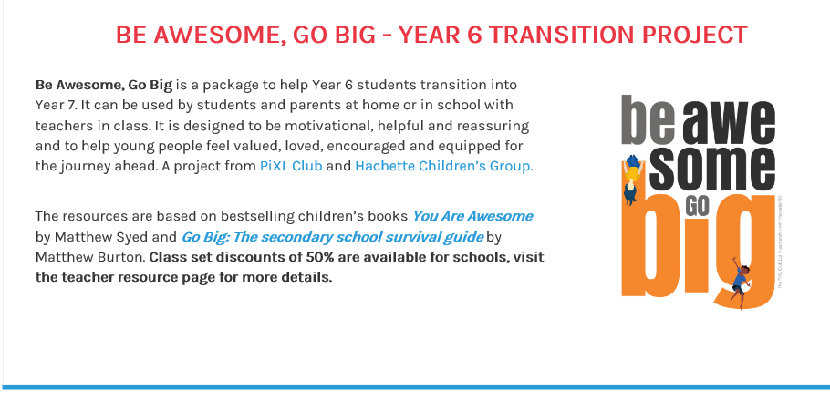
https://www.hachetteschools.co.uk/landing-page/hachette-schools/be-awesome-go-big-in-association-with-pixl/

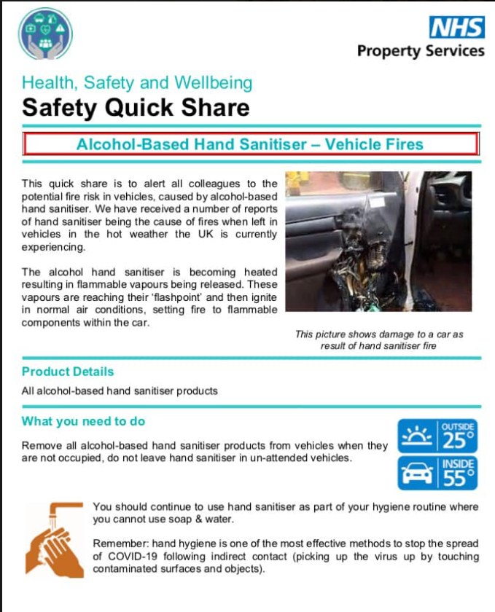

TRAINING

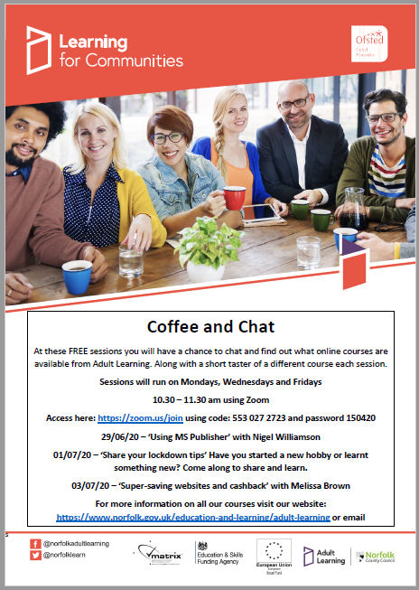

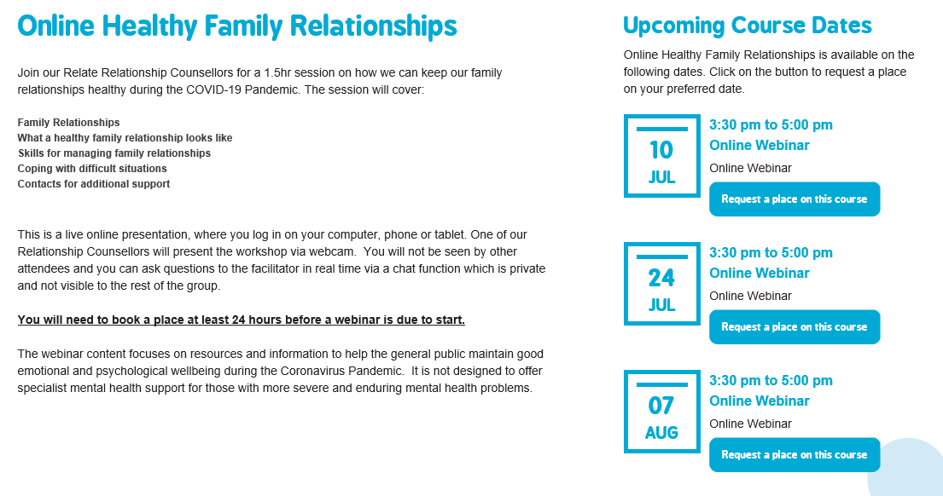

Visit https://www.wellbeingnands.co.uk/norfolk/course/healthy-family-relationships/ for more information and to book a course

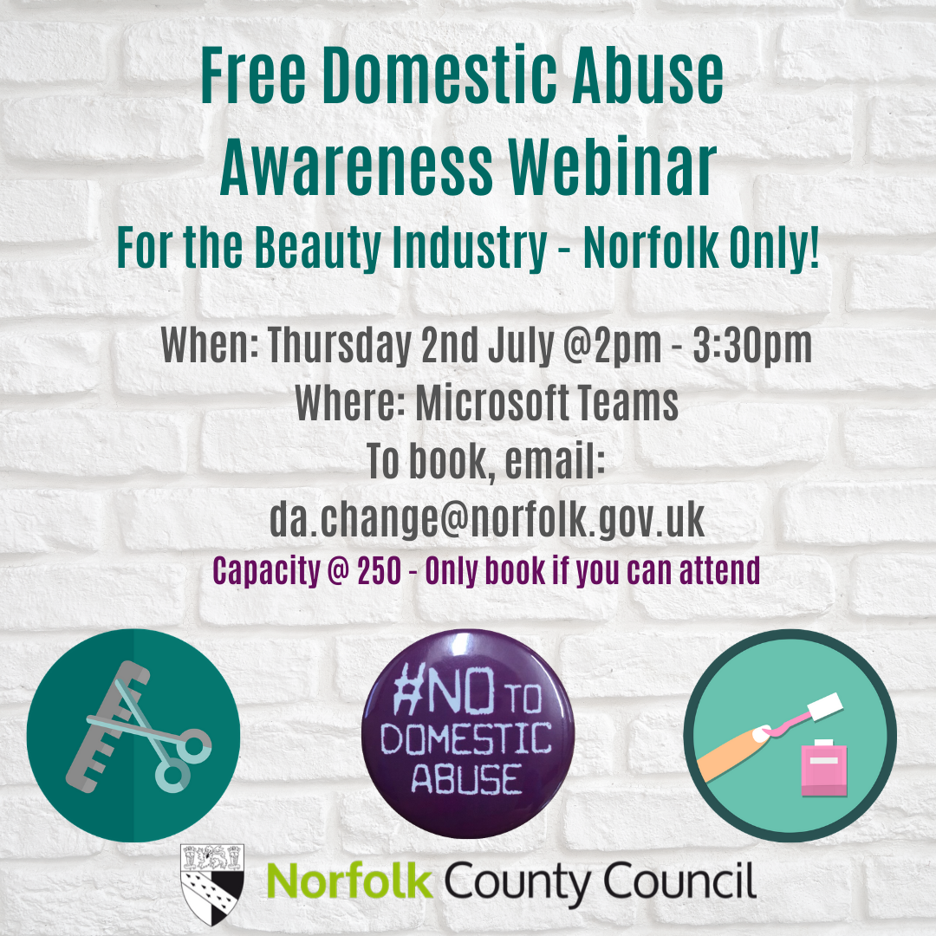

SUPPORT SERVICES

Essential Sequential Comic Drawing Workshops

I’m currently reaching out to people and organisations working with women in Norwich and surrounding areas to tell them about Essential Sequential’s new Lottery Community funded project “Sharing Stories”.

Sharing Stories is a 12 month project with the aim of producing comics co-creatively with women and people identifying as female currently experiencing (or at risk of experiencing) loneliness, isolation and their associated effects on wellbeing.
Essential Sequential’s previous projects have included;
- Facilitating teams of long-term unemployed men and women in Gt Yarmouth to create an ongoing manga series distributed within the community.
- Co-creating comics with young people facing marginalisation working with partners including MAP, Connects & Co, Norwich International Youth Project (NIYP) and YMCA.
- Running comic creation workshops and activities for Arts Council National Portfolio organisations such as Seachange Arts and Norfolk & Norwich Festival.
If you work with any women or people identifying as female who you think would enjoy and benefit from working collaboratively to create comics (either in person or remotely through Zoom, file sharing and snail mail!) I would love to discuss providing some taster workshops or activities for you and your organisation.

If you think this is something that would benefit your organisation and the people it works with please get in touch by replying to this email or calling me on 07747 520 118

I look forward to hearing from you!

Kind Regards

Stuart Paterson
Project Coordinator

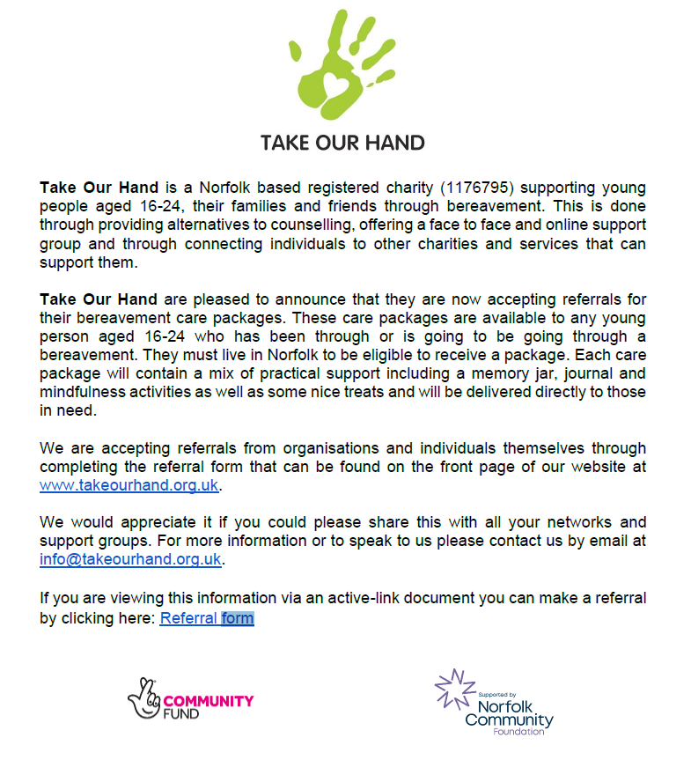
Able Futures can help you manage your mental health at work so you can enjoy more good days. We could give you nine months advice and guidance from a mental health specialist who can help you learn coping mechanisms, build resilience, access therapy or work with your employer to make adjustments to help your mental health at work.
Call Able Futures free on 0800 321 3137 from 8am to 10.30pm, Monday to Friday or apply online.
Able Futures delivers the Access to Work Mental Health Support Service on behalf of the Department for Work and Pensions. It could be available to you if you can answer "yes" to the following questions:
- Are you aged 16 or over?
- Are you in work, on an apprenticeship, about to start work or furloughed?
- Do you live in Great Britain?
- Do you have mental health difficulties that impact upon your work?
This list is not exhaustive and it is ultimately up to the Department of Work and Pensions Access to Work Mental Health Support Service adviser to determine eligibility.

https://able-futures.co.uk/mental-health-support-for-individuals/

FUNDING

https://www.avivacommunityfund.co.uk/

The COVID-19 outbreak is a challenging time for many. We know that now, more than ever, small charities need our support. That is why we have broadened the criteria of the Aviva Community Fund to include applications for projects that enable causes to adapt or continue their vital services by covering core running costs, so they can help their beneficiaries and communities during this time of need. See updated terms and conditions.
Applications are now open for the next round of the Aviva Community Fund until 28th July.

